# Vintage Iron Riders

A Vintage Motorcycle Club founded in 2003 whose members are primarily located in Central Illinois

Cen

# Vintage Iron Vintage Motorcycle Club founded in 2003 whose members are primarily located in Central Illinois

January 8, 2022

Vintage Iron Monthly

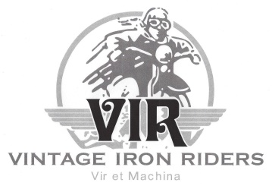

President’s Prattle

**Hit the Ground Running**

As we look forward to a New Year, our hopes for an improvement over 2021 will be enhanced if we are ready for what 2022 brings.*  For example, “Charles’s Law” tells us that tire pressures drop when air temperature drops.  That means, now that it is colder outside, we should check our tires and add air if necessary.  Also, this is when I go through my wallet and check expiration dates on memberships and licenses.  This examination should include everything from club memberships to FOID to driver’s license to your library card.

No question about it: We have a new year, folks.  It is up to us to start it right.

No amount of preparation can guarantee that our meetings and events will always go as planned.  The most we can do is the three Big Ps: plan, prepare, and pray.  The year holds much in store for us, despite any uncertainties.  Motorcycling tends to be an outdoor activity, and Vintage Iron Riders will take full advantage of that feature.  If worse comes to worse, there will still be open air meetings, the annual picnic, the weenie roast, and – of course rides.  With any luck at all, 2022 will be a fine year for our club.

One final thought: We all have people in our lives whom we truly appreciate and who exhibit qualities we admire.  I can sincerely say that a good number of these fine individuals in my life are also in Vintage Iron Riders.  That is the reason I enjoy our meetings and events so much.  Thank you for enriching my life.  I can hardly wait to do more!

* Note: My “be prepared” spiel does not mention COVID-19 vaccination.  I doubt if there is anything I can say here that will influence people to do that or not.

Inside this issue:

Upcoming Events 2

Member Meeting Minutes 2-3

Tech Tip 3-9

Joke of the Month 9

Product of the Month 10

Past Event Follow-up 11-15

Contact Information 16

Classified Ads 16



Meetings held at 7:00 pm every 3rd Wednesday of each month at Top Cats Chill and Grill located at:  3211 Sangamon Ave., Springfield, IL.  217-528-4201

**Next Member Meeting**

**January 19, 7:00pm**

Upcoming Club Events

* 1/19/22 – Monthly Member Meeting/Movie Night
* [2/13/22 – ABATE](https://www.facebook.com/photo?fbid=4893584817343078&set=gm.4827818027236360) Swap Meet



Movie Night

At this January’s member meeting we will be screening “The Indian Wrecking Crew”.

Narrated by Jay Leno. After WWII, two brands would battle for supremacy in the early days of American motorcycle racing - Harley Davidson and Indian. Three men, Bill Tuman, Bobby Hill and Ernie Beckman, racing for the Indian team, endured lethal heat, exhaustion and barely any pay. In spite of all this, they regularly dominated the better-equipped Harley riders and were dubbed the Indian Wrecking Crew. Their battles across the dirt tracks of America would define the burgeoning sport of motorcycle racing for years to come.

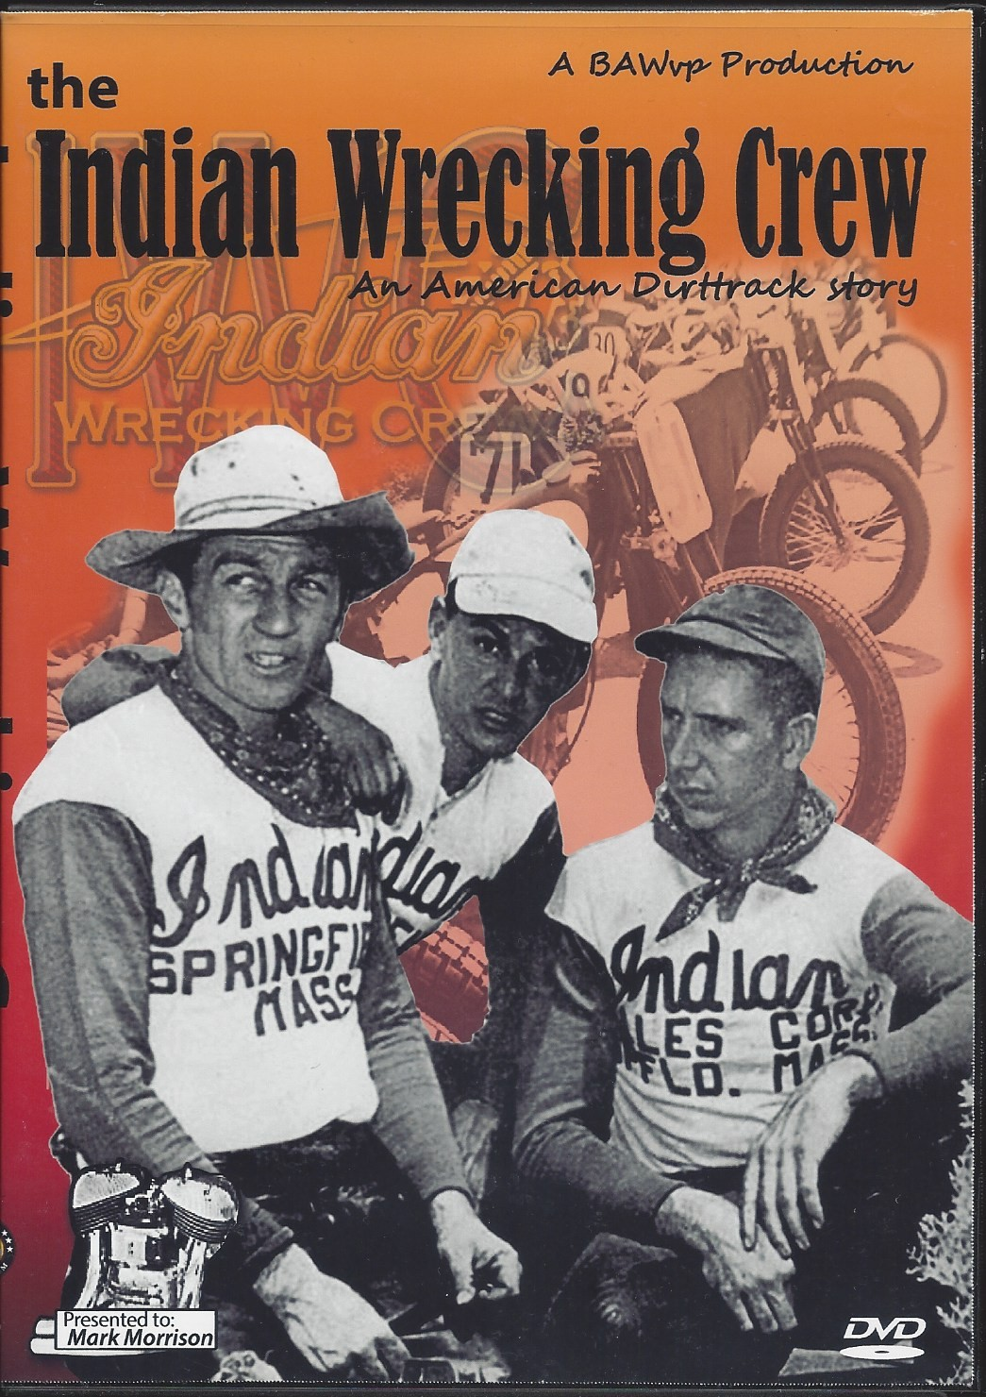

**Monthly Board Meeting**

**Reminder** **February 2, 7:00pm**

Monthly Board meetings held every first Wednesday of each month at 6:00pm at Bernie & Betty’s Pizza located at:  1101 South Spring Street, Springfield, Illinois. 217-528-8121. All members welcome.

***The purpose of this organization is to promote the motorcycling interests of its members in an atmosphere of fellowship and civility.***

***It includes helping establish contacts and communication with others whose experience, knowledge, and access to parts and materials might assist those members in the acquisition, restoration, maintenance, and use of antique and vintage motorcycles.***

***​***

***Above all, the purpose of this club is to have fun!***

Member Meeting Minutes

**December 3, 2021**

Meeting was called to order at 6:00 p.m. at Poe’s on the Hill. A Quorum was established.

* Please turn off cell phone
* The Flag of our Country was on display, and G led the Pledge of Allegiance
* George led Club in prayer
* Minutes approved as published
* George welcomed everyone to the Christmas party. “Merry Christmas and Happy Hanukkah.”
* Moment of silence in memory of Art Barto, Don Butler, and Bob Ramsey

**Reports:**

* Treasurer
  + Current Balances
    - Jeff White Memorial Fund $1,750.75
    - General Fund $3,675.69
    - Total $5,426.44
  + Approved by acclimation.
* Events
  + Excellent turnout at Sid Wood Memorial Toy Run with 60+ participants.
* Products
  + No report

**Old Business:**

* Election of Officers – Nominations Committee Report (John Langheim)
  + John “Fireball” Anderson has accepted the Vice President’s position.
  + John Langheim has accepted the Events Coordinator position.
  + John Langheim proposed changes to the Events Coordinator position. Beginning in 2022 each event will have its own committee chair. This will lighten the load and get more members involved. The chair will be responsible for showing other members the “ropes” of the event so we will have backups ready to set up. George motioned to accept proposal, Mark seconded, passed. The Committees chairs are as follows:
    - * Picnic – Dan Kerns
      * Movie Night – Mark Morrison
      * Park and Display – Gary Underfanger
      * Wiener Roast – Tammi Underfanger
      * Christmas Party – Tammi Underfanger
  + Roy Sims has accepted the Products Coordinator position.
  + The new officers were elected by acclimation.

**New Business:**

* None

**Sickness and Distress**

* None

Adjourned at 6:27pm

Tech Tip

**Vibrations from a motorcycle engine can damage your iPhone cameras**

HIGHLIGHTS

* Apple iPhones with OIS and closed-loop AF are vulnerable to damage.
* Apple recommends the use of a vibration damning mount for mounting iPhones on motorcycles.
* Many users have reported such damage over the last few years.



Android phones with OIS might be similarly susceptible to such damages.

Apple has warned that exposing [iPhones](https://www.digit.in/apple-mobile-phones/)to vibrations in certain frequency ranges, especially the sorts generated by a high-powered motorcycle engine can hamper the camera quality of your iPhone or irreparably damage the cameras altogether.

It’s quite common for bike riders to mount their phones on bike handles for navigation, and over the years, several users have reported such damage online across support forums. Apple has explained why this happens and it’s not just the iPhones that this warning might be pertinent to. High-end Android phones with OIS should be equally susceptible to damage.

**WHY YOU SHOULDN’T MOUNT YOUR PHONE ON A MOTORCYCLE**

Apple says that iPhone models with OIS that include all iPhones starting from [iPhone 6](https://www.digit.in/reviews/mobile-phones/apple-iphone-6-review-4349.html) and models with closed-loop Auto-focus that include iPhone XS and later, will be vulnerable to high-intensity vibrations. The [iPhone SE (2nd gen)](https://www.digit.in/reviews/mobile-phones/apple-iphone-se-2020-review-195929.html) is also included in the list. Both OIS and Closed-loop AF systems involve sophisticated mechanisms to move lens assembly for the best possible image quality.

"The OIS and closed-loop AF systems in iPhone are designed for durability. However, as is the case with many consumer electronics that include systems like OIS, long-term direct exposure to high-amplitude vibrations within certain frequency ranges may degrade the performance of these systems and lead to reduced image quality for photos and videos. It is recommended to avoid exposing your iPhone to extended high-amplitude vibrations."

The Ultra-wide camera sensor and Telephoto camera on these iPhones don’t have OIS, so the damage will be mostly to the primary sensor.

Apple further says that mounting your iPhone to handlebars of vehicles with relatively lower-amplitude vibration engines such as scooters and mopeds might not be as risky, but users are still advised to use a vibration-damping mount.

Joke of the Month



Product of the Month

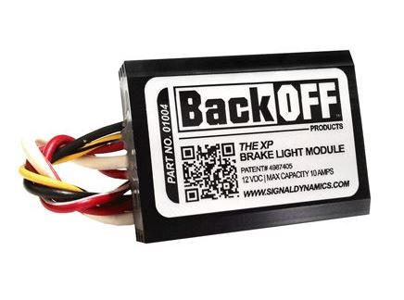

### **SIGNAL DYNAMICS BACKOFF XP BRAKE LIGHT MODULATOR**

As riders, it’s crucial to take proactive measures to lessen the likelihood of an accident or injury while in the saddle, and while that includes donning appropriate gear and arming yourself with proper training, that also means doing what you can to improve your ability to be seen by other drivers while out on the road. And that’s the idea behind Signal Dynamics’ BackOFF XP Brake Light Modulator. With a bike’s stock brake/taillight running through this module, when the front or rear brake is activated, it will repeatedly flash rather than simply lighting up, making you and your bike far more noticeable.

[Fully weatherproof](https://hiconsumption.com/essentials-best-weatherproof-gear/) and packing solid-state electronics, the BackOFF XP module can operate in one of two modes: either flashing three times and then reverting to the steady stock glow; or a triple flash, following by 3.5 seconds of steady glowing, before repeating over and over again for as long as the brake remains activated. Being rear-ending by a car is one of the most dangerous situations a motorcyclist can face, and because this product mitigates the likelihood of that happening by better grabbing drivers’ attention, we’d say that alone makes this sub-$50 product worth the investment, especially if you don’t live in a region where lane-splitting is legal.

[Available here for $47.95](https://www.revzilla.com/motorcycle/signal-dynamics-backoff-xp-brake-light-modulator?sku_id=1192728)

Club Products

There is a lot of activity around club products. John Langheim announced that Roy Sims has accepted the position of Products Coordinator at our Christmas Party. Roy is looking to update the process. At our January 5th Board meeting the Board authorized $250 to Roy Sims to purchase club merchandise for stock. This stock will be available for purchase at monthly member meetings.

In addition, Roy has established a new program to order specialty products. To use this option:

1. Go to [www.sanmar.com](http://www.sanmar.com) . The webpage you see below will display.

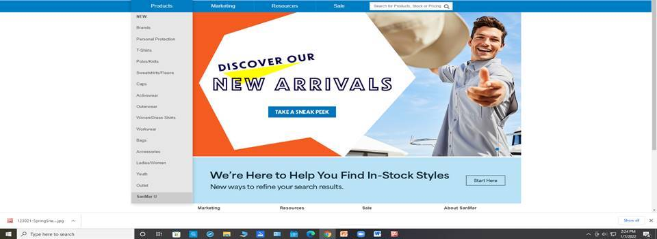

1. Once there, peruse the site to find a product you want to purchase.
2. Note the following information:
   1. Product number
   2. Product description
   3. Product size
   4. Product color
   5. Club logos:
      1. Logo size
      2. Logo placement on product
      3. Logo colors
3. Provide information to Roy and he will place order. Roy can be contacted at 217-721-8446 or by email [roy.sims@comcast.com](mailto:roy.sims@comcast.com)
4. When product arrives, Roy will make arrangements to receive payment and delivery.

Our goal is to provide a valued service to club members. Please bear with us as this process is new to all of us and not all factors are not within our control.

Contacts

Vintage Iron Riders

3985 N. 8th Street Rd. Springfield, IL 62707

<https://www.virmc.com/>

**Visit us on Facebook**

[](https://www.facebook.com/groups/1020653317952869/)

**Officers**

President - George Tinkham

Phone 217-753-2737

Email [coolbreeze@att.net](mailto:coolbreeze@att.net)

Vice Pres – John Anderson

Phone 217-725-4509

Email [fireball398@gmail.com](mailto:fireball398@gmail.com)

Treasurer - Mandi Powell

Phone 217-416-5575

Email [mandiu828@aol.com](mailto:mandiu828@aol.com)

Sec/ News/Web - Mark Morrison

Phone 309-662-5371

Email [mmorr26407@aol.com](mailto:mmorr26407@aol.com)

Events – John Langheim

Phone 217-652-8996

Email [langheim729@comcast.net](mailto:langheim729@comcast.net)



Classified Ads

Vapor blasting services. Vapor blasting is a surface refinishing process that was originally used by Rolls Royce in England many years ago, to clean and resurface aluminum jet engine parts to eliminate corrosion and facilitate inspection. It is quite simply cleaning via high-pressure surface blasting, but instead of dry abrasive media, it uses a slurry of water, compressed air, detergents and abrasive media. The vapor created is much gentler to soft aluminum than other processes, yet it will remove a microscopic layer of oxidized metal and corrosion. This process also seals the pores of the aluminum making it look better longer, and be more resistant to future corrosion. Vapor blasting differs from dry blasting in other respects as well – it will not dimensionally change a part, the media used is much finer and gentler, and the resulting surface is much smoother and shinier.

Contact Mark Morrison at 309-510-4189 or [mmorr26407@aol.com](mailto:mmorr26407@aol.com) if interested.

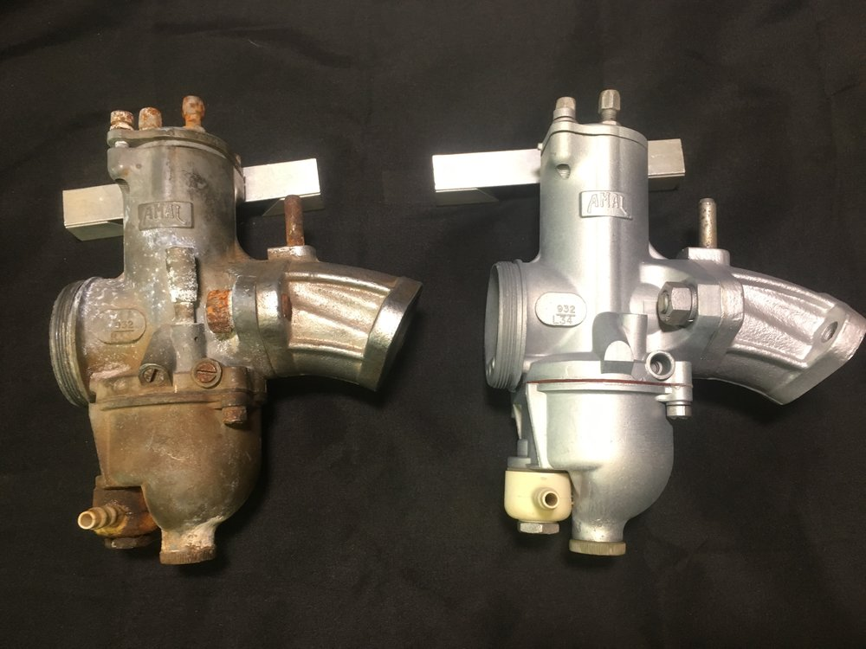

Before and after pictures

**Send classified submissions to Mark Morrison at** [**mmorr26407@aol.com**](mailto:mmorr26407@aol.com)

**“Get your kicks on RT66!”**