# Vintage Iron Riders

A Vintage Motorcycle Club founded in 2003 whose members are primarily located in Central Illinois

Cen

# Vintage Iron Vintage Motorcycle Club founded in 2003 whose members are primarily located in Central Illinois

February 8, 2022

Vintage Iron Monthly

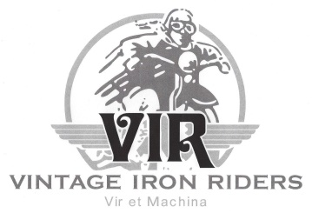

President’s Prattle

**Hit the Ground Running**

As we look forward to a New Year, our hopes for an improvement over 2021 will be enhanced if we are ready for what 2022 brings.\*  For example, “Charles’s Law” tells us that tire pressures drop when air temperature drops.  That means, now that it is colder outside, we should check our tires and add air if necessary.  Also, this is when I go through my wallet and check expiration dates on memberships and licenses.  This examination should include everything from club memberships to FOID to driver’s license to your library card.

No question about it: We have a new year, folks.  It is up to us to start it right.

No amount of preparation can guarantee that our meetings and events will always go as planned.  The most we can do is the three Big Ps: plan, prepare, and pray.  The year holds much in store for us, despite any uncertainties.  Motorcycling tends to be an outdoor activity, and Vintage Iron Riders will take full advantage of that feature.  If worse comes to worse, there will still be open air meetings, the annual picnic, the weenie roast, and – of course rides.  With any luck at all, 2022 will be a fine year for our club.

One final thought: We all have people in our lives whom we truly appreciate and who exhibit qualities we admire.  I can sincerely say that a good number of these fine individuals in my life are also in Vintage Iron Riders.  That is the reason I enjoy our meetings and events so much.  Thank you for enriching my life.  I can hardly wait to do more!

* Note: My “be prepared” spiel does not mention COVID-19 vaccination.  I doubt if there is anything I can say here that will influence people to do that or not.

Inside this issue:

[Upcoming Events 1](#Upcomingevents)

[Member Meeting Minutes 2](#Membermeetingminutes)

[Tech Tip 3-9](#TechTip)

[Joke of the Month 10](#jokeofthemonth)

[Product of the Month 11](#Productofthemonth)

[Club Products 12](#clubproducts)

[In Memory 13](#InMemory)

[Contact Information 13](#Contacts)

[Classified Ads 13](#classifedads)



Meetings held at 7:00 pm every 3rd Wednesday of each month at Top Cats Chill and Grill located at:  3211 Sangamon Ave., Springfield, IL.  217-528-4201

**Next Member Meeting**

**February 16, 7:00pm**

Upcoming Club Events

* [2/13/22 – ABATE](https://www.facebook.com/photo?fbid=4893584817343078&set=gm.4827818027236360) Swap Meet



Member Meeting Minutes

**January 19, 2022**

Meeting was called to order at 7:15 p.m. at Top Cat’s. A Quorum was established.

* Please turn off cell phone
* The Flag of our Country was on display, and George led the Pledge of Allegiance
* George led Club in prayer
* Minutes approved as published

**Reports:**

* Treasurer
  + Current Balances
    - Jeff White Memorial Fund $1,465.08
    - General Fund $3,326.28
    - Total $4,791.36
  + Approved by acclimation.
  + 2022 Dues are payable now.
* Events
  + Tonight is “Movie Night” with the *Indian Wrecking Crew* being shown.
  + Legion Riders have an event in latter part of July. F
  + John Anderson will provide more detail as available.
  + The Distinguished Gentlemen’s Ride is Sunday May 22.
* Products
  + Roy has ordered shirts for stock. Cost has gone up to $18.00. See Roy to get yours.
  + 2022 Calendars are in and can be purchased for $10.00

**Old Business:**

* None

**New Business:**

* Lance Gilbert was approved for membership.

**Sickness and Distress**

* None

Adjourned at 7:01 p.m.

**Monthly Board Meeting**

**Reminder** **March 2, 7:00pm**

Monthly Board meetings held every first Wednesday of each month at 6:00pm at Bernie & Betty’s Pizza located at:  1101 South Spring Street, Springfield, Illinois. 217-528-8121. All members welcome.

***The purpose of this organization is to promote the motorcycling interests of its members in an atmosphere of fellowship and civility.***

***It includes helping establish contacts and communication with others whose experience, knowledge, and access to parts and materials might assist those members in the acquisition, restoration, maintenance, and use of antique and vintage motorcycles.***

***​***

***Above all, the purpose of this club is to have fun!***

Tech Tip

**How to Change a Motorcycle Tire**

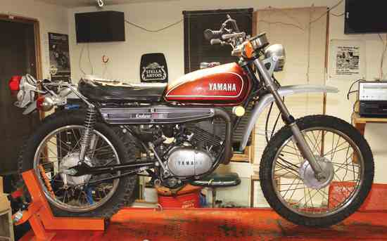

Editor’s Note: If you’re like me, I prefer to have my tires changed at the local shop with a tire machine. Years of crawling around on the garage floor and holes in tubes frustrate me. Of course there are times where a shop is not an option. In that case these tips will help you be successful (hopefully) the first try.

Changing tires isn’t a particularly fun or rewarding job, but like many chores, it’s a good one to know how to do when the occasion arises. Frankly, this issue’s How-To reminded us of how rusty we are at the job, rarely changing our own tires because A) it’s usually rolled into the cost of a new tire and B) you still need to get the wheel and tire balanced once you’re done, also usually rolled into the cost of a new tire.

If you want to change your own tires, there are a few tools to have on hand. You won’t use them all at one time, but they’re worth having and they’re relatively inexpensive, to boot. The lineup consists of a valve core tool for removing and installing valve cores ($4.95), a valve repair tool for cleaning threads on damaged valve stems ($5.95), a puller for fishing the valve stem on a tube through the rim hole ($11.95), a valve stem mounting tool for tubeless rims ($17.95), a set of tire irons ($25.95 each for heavy duty irons — extra leverage and strength is always nice — or $13.95 each for standard 11-inch irons — great for smaller tires and they’ll fit in a tank bag), and a set of rim protectors ($7.95 for the pair and especially appreciated with aluminum or cast rims). Everything mentioned here is from [BikeMaster](http://www.bikemaster.com/" \t "_blank), including the new tube ($12.95).

The biggest challenge can be getting an old tire off. Tires get stiffer with age, and tire beads have a tendency to weld themselves to the rim over time, making it hard to break the bead and pull the tire over the rim. It’s not unusual to have to cut off stuck and stiff decades-old tires to avoid damaging the wheel rim.

The front tire on our 1974 Yamaha DT125 Enduro didn’t put up much of a fight. With the valve core removed and the tire deflated, the bead broke with simple downward hand pressure. When that doesn’t work, push a tire iron between the bead and rim in one spot, then pry the iron down to push the bead down and off the rim, working around until it falls loose.

Rim protectors are great if you’re worried about marring your rim. We used them for the dismount, but we didn’t bother with them during remount as our new tire went on easily. If there’s a colored balance dot on your new tire, line it up with the valve stem hole. And finally, give the bead a light coating of soapy water or tire mounting paste to help the new tire slip over the rim.

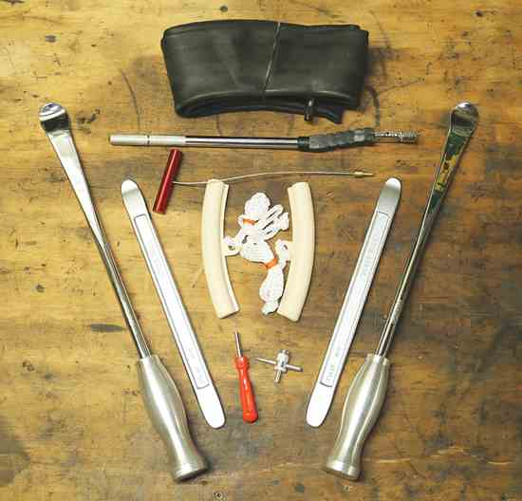

**1.** Tools of the trade: You won’t need them all at once, but it’s nice to have a good selection of tire tools ready at hand. The tool below the inner tube is for installing valves in tubeless rims.

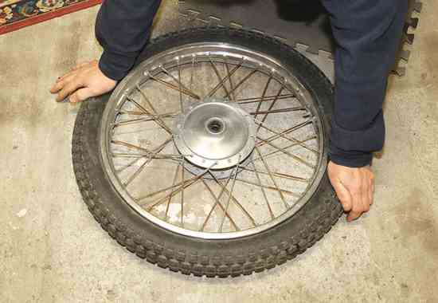

**2.** The first step is breaking the bead. With smaller tires you can usually do this by hand, pushing down on the deflated tire’s sidewall until it lets loose from the rim. If it won’t, break it loose with a tire iron placed between the rim and the bead, prying down on the iron.

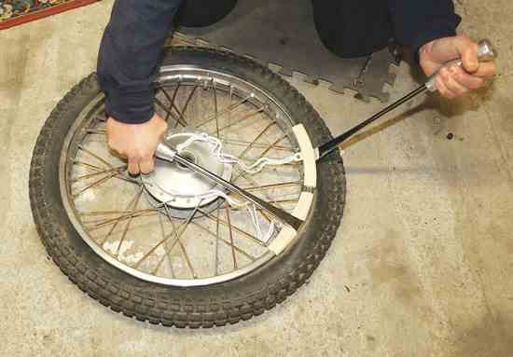

**3.** If you use rim protectors, put them on the rim first. Next, slip the tire irons behind the tire bead, then pry back and pull the bead up over the rim. Pry the bead up with one iron, then hold the iron down, following with the second to pull the bead up over the rim.

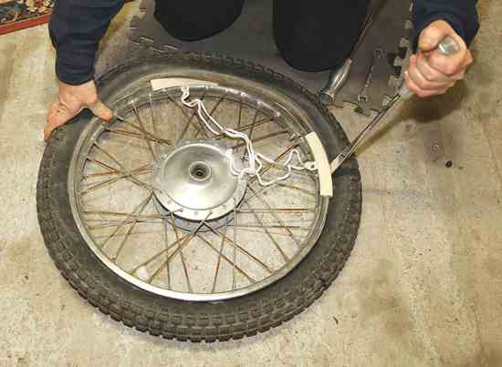

**4.** Old tires can be a bear to stretch over the rim, but ours pulled over fairly easily. Once started, reposition the rim protectors as needed and work around the rim until the tire is free.

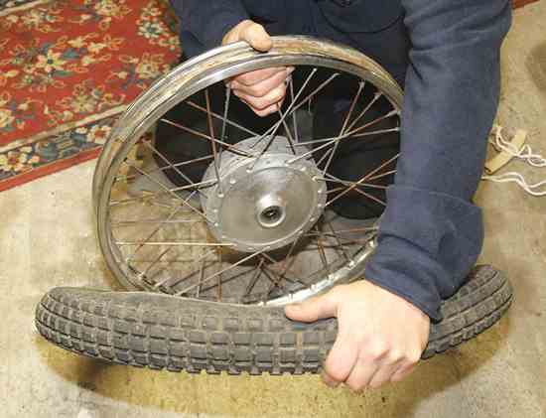

**5.** With one side off you can often push the other bead over the rim without using the tire irons. With the bead in the rim recess and the tire at its loosest, push it off as shown. It will usually roll off.

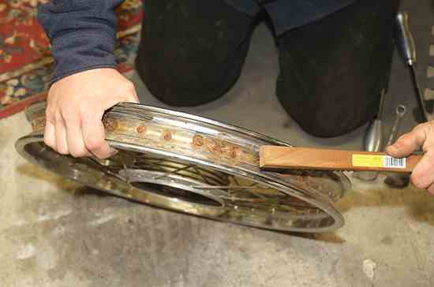

**6.** With the tire off, remove the rim strip (ours had completely deteriorated) and clean the inside of the rim. Our steel rim had a quite a bit of rust. If this was a daily rider we’d consider replacing it, but since this bike only sees occasional field use we felt comfortable just cleaning off the loose scale.

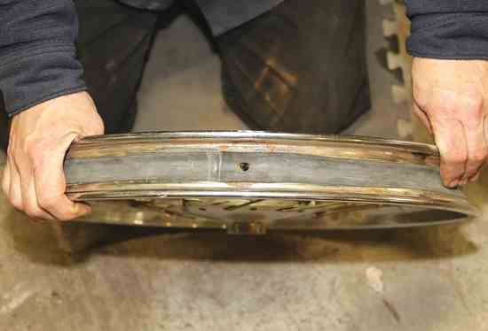

**7.** Although we didn’t bother, you can coat the inside of the rim with a rust treatment or use rust-resistant paint to help stave off future rust. Once the rim is cleaned stretch a new rim strip into place, making sure to center the hole for the valve stem.

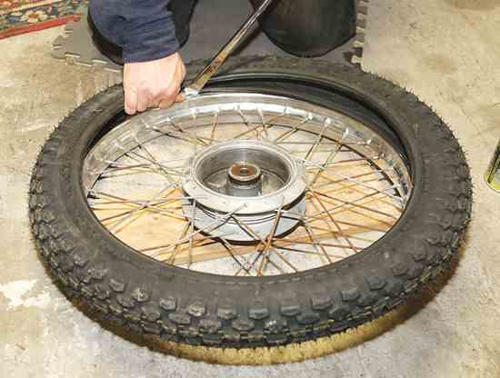

**8.** Lubricate the bead, position the new tire and push the inner bead over the rim in one spot. Work around the rim evenly left to right, pushing the bead down by hand. Use a tire iron to stretch the last bit of the tire over the wheel rim.

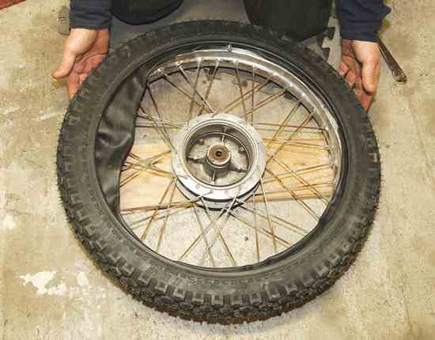

**9.** With one bead over the rim, put the tube inside the tire, with the valve centered on the valve hole in the rim. Feed the tire valve through the rim and secure it loosely with its retaining nut. Make sure the tube is inside the tire and rim so it won’t get pinched when the bead is pushed down in the next step.

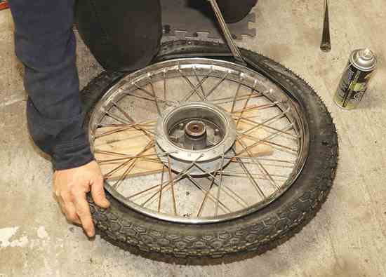

**10.** Starting at the valve, push the bead down into place by hand. Work around the tire evenly left to right, pushing down and finishing with a tire iron to stretch the last bit over the rim.

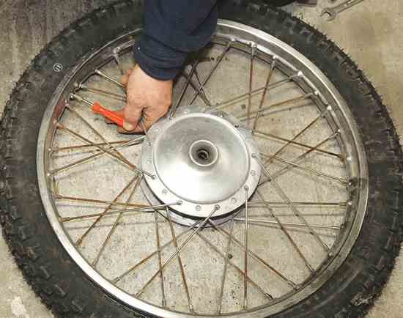

**11.** Tighten the valve stem retaining nut and install the valve core. Air up the tire, then remove the core and deflate it. Check that the bead is evenly seated on both sides. Reinstall the core, air the tire up to the appropriate pressure and install the valve cap.

**12.** If you have a static balancer, go ahead and balance the wheel. For low-speed dual-sport motorcycles, balancing is generally optional.

Joke of the Month

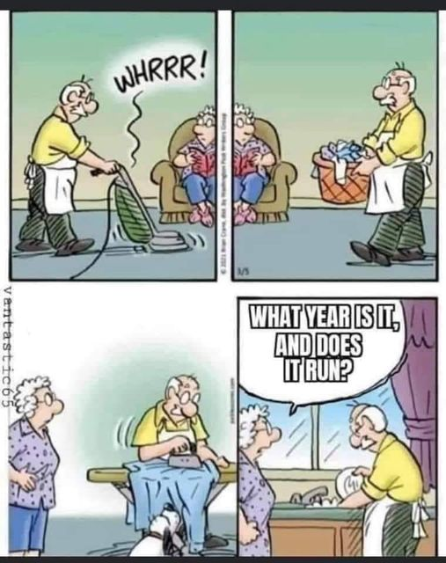

Product of the Month

**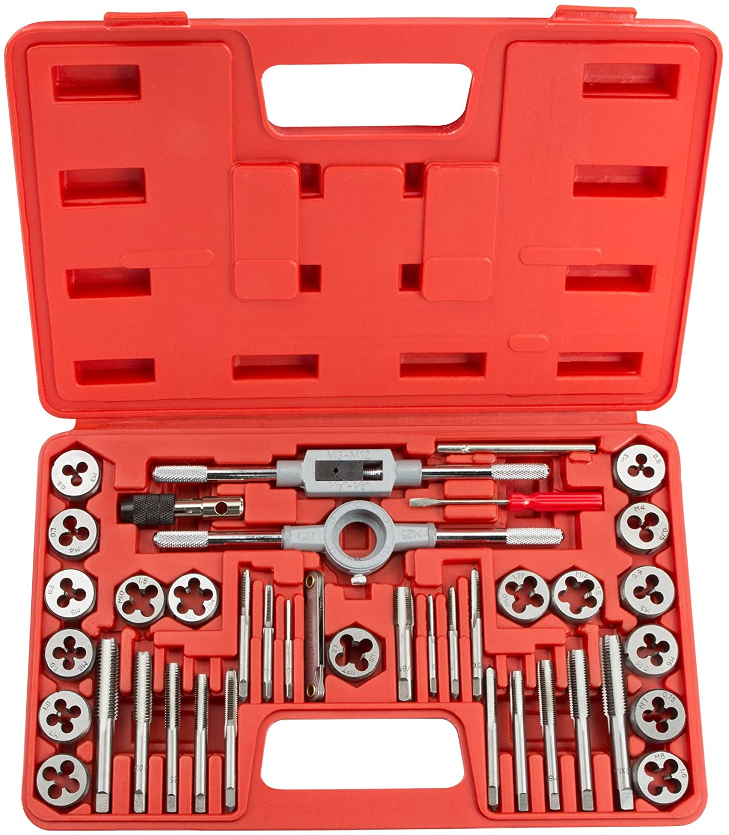**

### **Tap and Die set**

This is a must have tool for vintage motorcycle enthusiasts. A tap and die set is a two-in-one tool used to cut threads. You use the tap to cut threads on the holes where threads fasteners are positioned and use the die to cut threads on rods that are mainly from steel.

Dies are also for creating a fresh thread on newly formed bolts and repairing existing threads on bolts and screws.

A good tap and die set will completely change how you approach your projects. With such a set in hand, you can do things like repair old nuts and bolts in no time flat. And you can even create your own nuts and bolts from scratch!

Sets come in metric, SAE, and Whitworth to name a few thread types. However, the quality of the final product is only as good as the quality of your tools. That’s why it’s so important to find the best set you can afford for your needs. Hardware and big box stores normally carry the common type sets. Specialized sets can be found online.

Club Products

To order specialty products: To use this option:

1. Go to [www.sanmar.com](http://www.sanmar.com) . The webpage you see below will display.



1. Once there, peruse the site to find a product you want to purchase.
2. Note the following information:
   1. Product number
   2. Product description
   3. Product size
   4. Product color
   5. Club logos:
      1. Logo size
      2. Logo placement on product
      3. Logo colors
3. Provide information to Roy and he will place order. Roy can be contacted at 217-721-8446 or by email [roy.sims@comcast.com](mailto:roy.sims@comcast.com)
4. When product arrives, Roy will make arrangements to receive payment and delivery.

Our goal is to provide a valued service to club members. Please bear with us as this process is new to all of us and not all factors are not within our control.

In Memory



[**Jim (Wedge) Grahn, 65, passed away on Sunday, January 30, 2022**](https://www.legacy.com/us/obituaries/name/james-grahn-obituary?id=32599240&fbclid=IwAR32rV1j30aPllpnaraGu_ndeUAQrxZ7eQGkAu2lTnmzCgAOgzdDkKsPEfk)

Contacts

Vintage Iron Riders

3985 N. 8th Street Rd. Springfield, IL 62707

<https://www.virmc.com/>

**Visit us on Facebook**

[](https://www.facebook.com/groups/1020653317952869/)

**Officers**

President - George Tinkham

Phone 217-753-2737

Email [coolbreeze@att.net](mailto:coolbreeze@att.net)

Vice Pres – John Anderson

Phone 217-725-4509

Email [fireball398@gmail.com](mailto:fireball398@gmail.com)

Treasurer - Mandi Powell

Phone 217-416-5575

Email [mandiu828@aol.com](mailto:mandiu828@aol.com)

Sec/ News/Web - Mark Morrison

Phone 309-662-5371

Email [mmorr26407@aol.com](mailto:mmorr26407@aol.com)

Events – John Langheim

Phone 217-652-8996

Email [langheim729@comcast.net](mailto:langheim729@comcast.net)



Classified Ads

Vapor blasting services. Vapor blasting is a surface refinishing process that was originally used by Rolls Royce in England many years ago, to clean and resurface aluminum jet engine parts to eliminate corrosion and facilitate inspection. It is quite simply cleaning via high-pressure surface blasting, but instead of dry abrasive media, it uses a slurry of water, compressed air, detergents and abrasive media. The vapor created is much gentler to soft aluminum than other processes, yet it will remove a microscopic layer of oxidized metal and corrosion. This process also seals the pores of the aluminum making it look better longer, and be more resistant to future corrosion. Vapor blasting differs from dry blasting in other respects as well – it will not dimensionally change a part, the media used is much finer and gentler, and the resulting surface is much smoother and shinier.

Contact Mark Morrison at 309-510-4189 or [mmorr26407@aol.com](mailto:mmorr26407@aol.com) if interested.

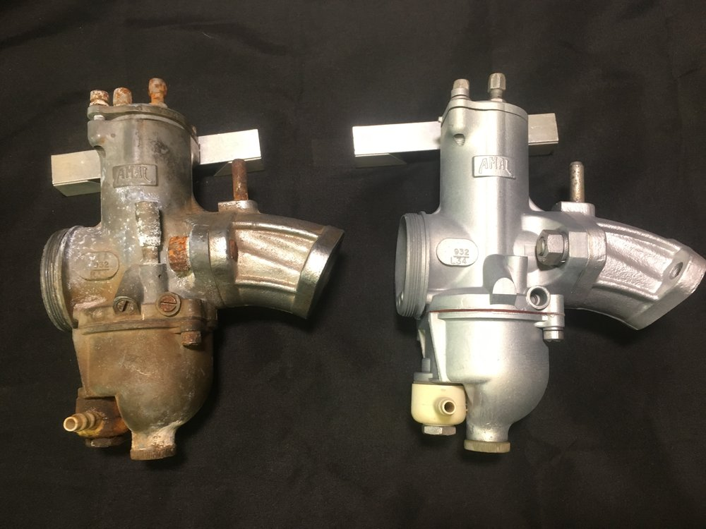

Before and after pictures

**Send classified submissions to Mark Morrison at** [**mmorr26407@aol.com**](mailto:mmorr26407@aol.com)

**“Get your kicks on RT66!”**