# Vintage Iron Riders

A Vintage Motorcycle Club founded in 2003 whose members are primarily located in Central Illinois

Cen

# Vintage Iron Vintage Motorcycle Club founded in 2003 whose members are primarily located in Central Illinois

April 14, 2022

Vintage Iron Monthly

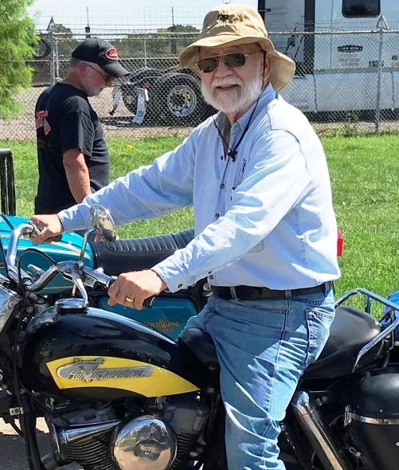

President’s Prattle

**It is Here!**

**(Spring, that is.)**

Our first monthly meeting of spring will be Wednesday, April 20th.  Let’s hope for good weather and good health so we can make the most of that evening.  We might even be able to meet outdoors if it is warm and dry enough.  The insects will not be out yet; so, we might as well be outside.

With pandemic fears subsiding and pent up demand for motorcycle related activities abounding, 2022 promises to be a fun year for Vintage Iron Riders.  Remember, there will be numerous events where Vintage Iron Riders is not a sponsor, but where our presence will be appreciated.  For example, the A.B.A.T.E. Easter Basket Run to Hope School is scheduled for Friday, April 8th.  We meet at noon at County Market on South Grand Avenue East and Dirksen Parkway.  Kickstands go up at 12:45 PM.  Incidentally, there may be a shortage of baskets for these kids; so, our involvement would be especially appreciated.  Please bring at least one basket of candy, coloring book, small toy, etc.  No hard candy please.  A notice of this event is posted below and on our Facebook site.

Another event coming soon is the annual A.B.A.T.E. Freedom Rally on May 3rd.  A notice of this event is posted below and on our Facebook page.  I really like this event because hundreds of fellow bikers from around the State gather at the Illinois Department of Transportation building parking lot at 2300 S. Dirksen Parkway in Springfield before noon.  I love checking out the various bikes and socializing with people I get to see just a few times a year.  We ride from IDOT to the west side of the Capitol parade style where politicians regale us with how much they are committed to promote motorcycling friendly legislation.  It is a short event, but it is a good reminder to motorists that motorcycle season has started.  After all, May is “Motorcycle Awareness Month.”

Vintage Iron Riders has adopted the “Distinguished Gentlemen’s Ride” on May 23rd as a club event.  We will discuss this further at our April and May meetings.  Meanwhile, mark that date.

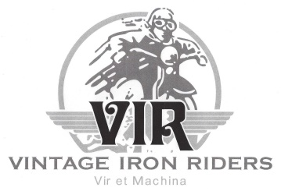

Inside this issue:

[Upcoming Events 3-4](#UpcomingClubEvents)

[Member Meeting Minutes 5](#Membermeetingminutes)

[New Club Business Card 6](#NewClubBusinessCards)

[Member Recognition 7-9](#MemberRecognition)

[Industry News 9-12](#IndustryNews)

[Tech Tip 13-16](#TechTip)

[Joke of the Month 16](#jokeofthemonth)

[Product of the Month 17](#Productofthemonth)

[Club Products 18](#clubproducts)

[Sickness and Distress 19](#SicknessandDistress)

[Contact Information 20](#Contacts)

[Classified Ads 20](#classifedads)



Meetings held at 7:00 pm every 3rd Wednesday of each month at Top Cats Chill and Grill located at:  3211 Sangamon Ave., Springfield, IL.  217-528-4201

**Next Member Meeting**

**April 20, 7:00pm**

It is great to see our members participate in these events.  It is also great to see Vintage Iron Riders recognized as a worthy part of the motorcycling environment of Central Illinois.  Along with the social and club promotion aspects, these events are opportunities to display our bikes.

Let’s stop living under the cloud of the pandemic and start embracing opportunities to enjoy motorcycling events.  Use whatever health safety approaches you feel are appropriate, and treat yourself to wholesome outdoor activities that motorcycling offers.  Whether you ride or reminisce, you will find much to do and to see.  Come and join us at these events and have some fun.

After all, life is better with fun it!

George Tinkham

Springfield, Illinois

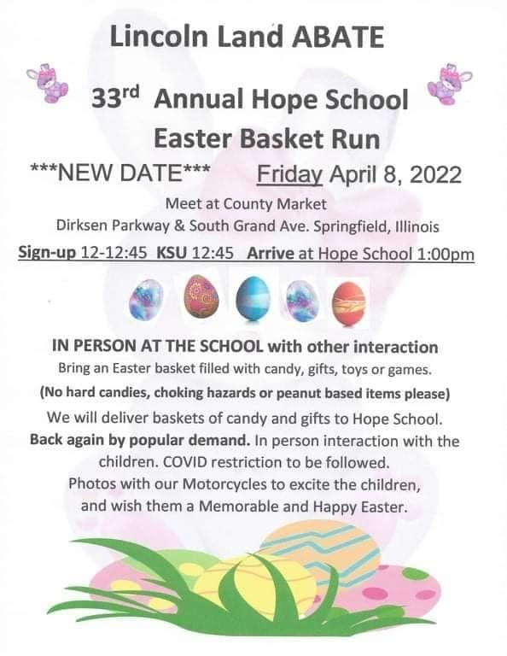



****

**Monthly Board Meeting**

**Reminder** **May 4, 6:00pm**

Monthly Board meetings held every first Wednesday of each month at 6:00pm at Bernie & Betty’s Pizza located at:  1101 South Spring Street, Springfield, Illinois. 217-528-8121. All members welcome.

***The purpose of this organization is to promote the motorcycling interests of its members in an atmosphere of fellowship and civility.***

***It includes helping establish contacts and communication with others whose experience, knowledge, and access to parts and materials might assist those members in the acquisition, restoration, maintenance, and use of antique and vintage motorcycles.***

***​***

***Above all, the purpose of this club is to have fun!***

Upcoming Club Events

* 4/8/22 – [Lincoln Land ABATE 33 Annual Hope School Easter Basket Run](https://www.abate-il.org/Lincolnland/newsletters/22-04.pdf), Springfield, IL
* 5/1/22 – [Illinois ABATE Freedom Ride](https://www.abate-il.org/Lincolnland/newsletters/22-04.pdf)
* 5/13/22 – 8/3/22 – [Rumble Around the Lake](https://www.facebook.com/RumbleAroundTheLake/photos/a.400188113723952/1290776474665107/)
* 5/22/22 - [The Distinguished Gentleman's Ride](https://www.gentlemansride.com/join/VintageIronRiders) (see additional information below)
* 6/5/22 – Club picnic, Chatham, IL
* 6/5/22 – James “Wedge” Grahn Celebration of Life, Auburn, IL
* 7/23/22 - American Legion Cruise In & Open House. Club is planning to participate.
* 9/3/22 -9/4/22 – Springfield Mile/Park and Display, Springfield, IL
* 9/10/22 [Tail O'The Possum Benefit Ride](https://www.facebook.com/groups/1491009324526836)
* 12/9/22 - Annual Christmas Party 6:00PM, Poe’s On the Hill, Springfield.

**The Distinguished Gentlemen’s Ride**

Vintage Iron Riders is participating in this year's Distinguished Gentleman's Ride on Sunday May 22, 2022. Club member John Richardson is coordinating the ride. To participate please register at <https://www.gentlemansride.com/join/VintageIronRiders>. The Ride is a global motorcycle event raising funds and awareness for prostate cancer research and men's mental health programs on behalf of the Movember Foundation.

Open to all genders, The Distinguished Gentleman's Ride was founded in 2012 by Mark Hawwa in Sydney, Australia, and is centered on classic and vintage styled motorcycles. While the event encompasses classic and vintage style, it also welcomes niche custom motorcycle styles such as cafe racers, choppers, scramblers, and more.

The ride provides an outline of dress and behavior, suggesting riders wear dapper clothing, silk vests, tweed suits and behave courteously, donning not only classic style, but classic manners. Suggested motorcycles for the themed ride include café racers, bobbers, classics, modern classics, flat trackers, scramblers, old school choppers, brat styled, classic scooters, and classic sidecars. The ride carries no entry fee; however, some rides require minimum donation amounts to join. All riders are encouraged to raise funds for prostate cancer research and men's mental health programs on behalf of charity partner the Movember Foundation.

The planned route is: Starting at Hardees at 2501 Stevenson, east to East Lakeshore Drive, south to Pawnee Rd, east on New City Rd through Sangchris Lake SP, south on CR 20, then CR 5 to Rte 104 at Kinkaid, west to Pawnee, then north on Pawnee Rd back to East Lakeshore Drive and to Hardees.  It is about 48 miles.

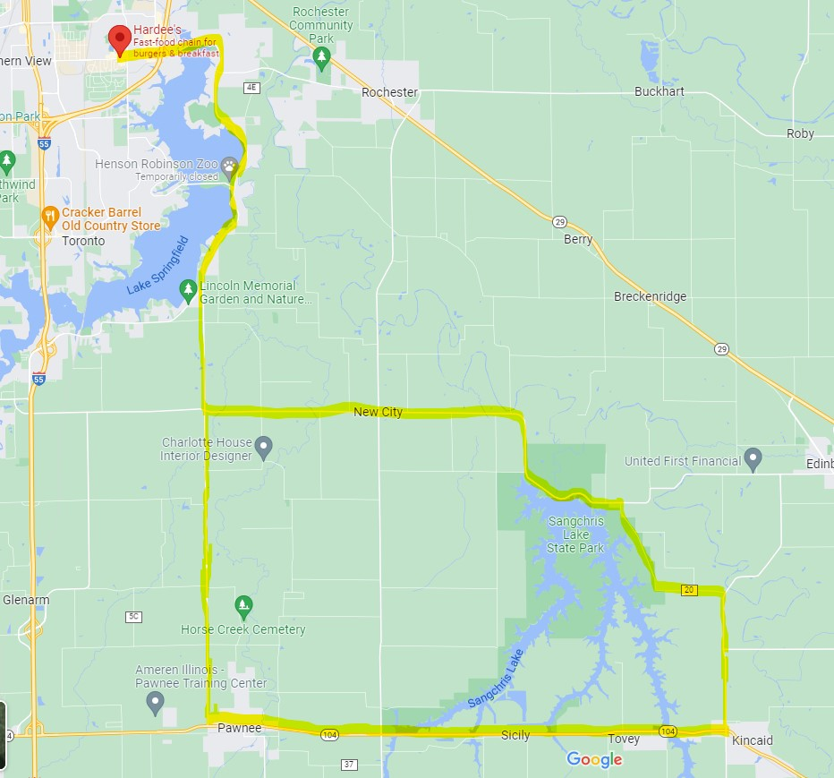

Planned Ride Route

Additional information can be found at <https://www.gentlemansride.com/Vintage>

Member Meeting Minutes

**February 16, 2022**

Meeting was called to order at 7:16 p.m. at Top Cat’s. A Quorum was established.

* Please turn off cell phone
* The Flag of our Country was on display, and George led the Pledge of Allegiance
* George led Club in prayer
* Previous Minutes approved as published

**Reports:**

* Treasurer
  + Current Balances
    - Jeff White Memorial Fund $1,716.08
    - General Fund $2,885.13
    - Total $4,601.11
  + Approved by acclimation.
* Events
  + Annual Club picnic will be June 6 in Chatham.
  + Club plans a Jim Grahn Memorial ride this spring.
  + Plans are developing for annual wiener roast this fall.
  + Rumble Around the Lake is starting up soon. Club is planning to participate in some stops.
  + The Distinguished Gentleman's Ride is Sunday, May 22nd, 2022
  + July 23 is the American Legion Cruise In & Open House. Club is planning to participate.
  + George is looking at a Ride-To-Ron’s this year in the fall.
  + 12/9/22 - Annual Christmas Party 6:00PM, Poe’s On the Hill, Springfield.
* Products
  + All 2022 Club Calendars are sold out.
  + New Club business cards with QR code are ordered (for additional information see article in this newsletter)
  + We are looking for a new Club patch supplier. Roy is trying to find a suitable vendor. Please let Roy know if you can help.
  + New Club T-shirts are in. See Roy to get one.

**Old Business:**

* None

**New Business:**

* Club member Craig Ashbaugh has been recognized with a prestigious award by the Antique Motorcycle Club of America (AMCA). More information is contained in article in this newsletter.
* New applicants Jeff “Jacques” Roberts and Linda “Sissy” Benedict approved by membership by Club.

**Sickness and Distress**

* 6/5/22 – James “Wedge” Grahn Celebration of Life, Auburn, IL

Adjourned at 7:45p.m.

New Club Business Card/Marketing Tool

VIR membership has approved the purchase of 500 new business cards to be used when recruiting prospective members. These will be a generic design containing a QR code. QR codes are the latest marketing tool and our hope is they will make it easier for prospective members to get club information. Cards will be available through John Anderson.

What is a QR Code and how do they work? They come to us from Japan where they are very common. QR is short for Quick Response (they can be read quickly by a cell phone through the camera function). They are used to take a piece of information from our business card and put it in to a cell phone. My first experience with them was to view a menu at a restaurant.

Once it is in your cell phone, it will direct the user to our website for additional club information. The reason why they are more useful than a standard barcode is that they can store (and digitally present) much more data, including url links, geo coordinates, and text. The other key feature of QR Codes is that instead of requiring a chunky hand-held scanner to scan them, many modern cell phones can scan them.

## How does the cell phone read the code? It depends on what type of cell phone is being used. But generally speaking, you:

1. Open your cell phone’s camera app.
2. Move your camera so the QR code is in the frame. If the code is easily scannable, you'll see the code's URL appear at the bottom of the frame. Tap it to open that URL.

The new cards will be double sided as displayed below. The back can be used to provide additional contact information to prospective members.



Front



Back

[Member Recognition](#MemberRecognition)

Club member Craig Ashbaugh has been recognized with a prestigious award by the Antique Motorcycle Club of America (AMCA). Craig was received national awards in AMCA’s Survivor / Unrestored Category at their Sunshine Chapter Meet in New Smyrna Beach, Florida for his 1975 Harley Davidson z90. The Z-90’s are rare made for only three years 1973, 1974, & 1975.

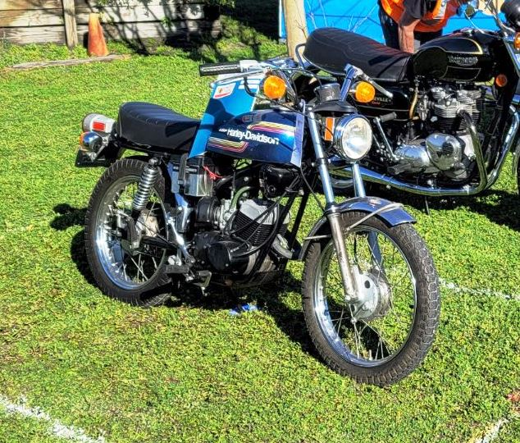

Craig’s 1975 HDz90

*“A survivor is a classic motorcycle that has not been altered in any way since it was built.”* Naturally, even the best-made vehicles experience natural wear and tear. Owners usually provide ongoing maintenance and replace parts that break down. They should have the original paint job and parts. It’s an added bonus to have documentation confirming the location and date of the vehicle’s original purchase.

Craig has shown this bike two times (2021, 2022) gathering the following awards:

* 2020 Mechanical Restoration (Sonny's M'cycle Repair / Lowell, MA)
* 2021 Junior First Award (97 3/4 points out of 100 possible)
* 2022 Senior Award (99 1/4 points out of 100 possible)

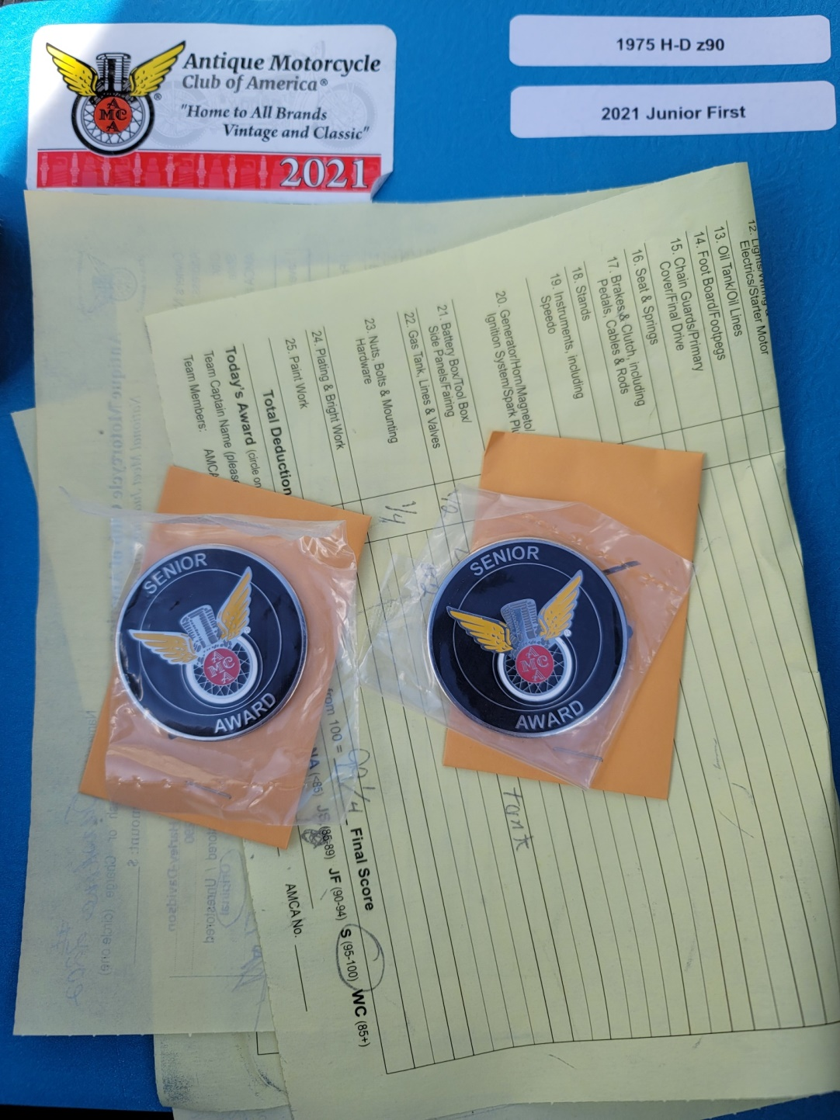

Craig's AMCA Awards

This is not the first time Craig has been recognized.  His 1985 Harley Davidson FLHTC also garnered a Senior Award in 2022 with 98 points. It took 3 years to achieve Senior status.

The  [AMCA](http://www.antiquemotorcycle.org/index.php" \t "_blank)  was founded in 1954 and has over 11,000 members!  The purpose of the club is “preservation, restoration and operation of old-time motorcycles.” Members of the AMCA own, restore, preserve, study or just admire motorcycles that fall into the antique category, meaning they are at least 35 years old (sounds like VIR) .

All motorcycles that are 35 years old or older are eligible for judging at AMCA national meets.  A motorcycle registered in the proper class is judged with other motorcycles in the same class.  All motorcycles are given 100 points at the start of the judging.  Judges deduct points according to accepted AMCA standards

They are judged based on being the closest to the original factory condition.  There are two categories of competition in the AMCA award system.  Motorcycles are judged in the junior category at AMCA national meets until they win the first place Junior Award.  After they have won the first place Junior Award they are eligible to be judged as senior motorcycles at a future national meet.

When the Senior Award is won, the motorcycle may enter the Winners Circle at future AMCA national meets, if a score of 98 points (new standard established in 2022) is maintained. The entrant will receive the “Winners Circle Preservation Award” plaque and the first insert tab showing the place of the meet, year, and make, model, year of motorcycle entered.  The motorcycle shall remain in the Winners Circle provided a minimum of 85 points is maintained to insure quality condition.

**Congratulations Craig!**

Industry News

This month we are starting a new feature called industry news. Its purpose is to bring significant motorcycle information before you. It will only appear as important issues come up in the motorcycle world. This month’s article is about ethanol fuel and comes via an American Motorcycle Association news release. As ethanol can cause damage to motorcycles this is something we all need to understand.

## **Ethanol-based fuels are not only harmful to motorcycle engines and the environment, they are often purposely mislabeled to keep consumers in the dark**

March 21, 2022

By Kali Kotoski

Photos: Jeff Kardas

Life is full of choices, but even at the gas station there can be bad ones if you’re not an informed motorcyclist.

For carbureted motorcycles and bikes manufactured before 2001, ethanol-laced gasoline can have negative effects on the motorcycle’s fuel system without proper maintenance and storage. But it can lead to costly mishaps for more modern fuel-injected motorcycles, too.

The big problem is that ethanol-laced gasoline is virtually everywhere, as it’s found in 98 percent of the country, according to the U.S. Department of Energy. Typically blended in at 10 percent ethanol, or E10, virtually every octane rating contains ethanol unless it is clearly marked as NO ETHANOL ADDED or ETHANOL FREE or NON-ETHANOL.

The labeling of ethanol-boosted and regular gas varies from state to state and supplier to supplier, making it even more confusing for the average citizen. Many would say that’s deliberately so, especially when talking about its polyonymous juiced-up cousin E15/Unleaded 88/88 Octane, which contains 15 percent ethanol and is illegal to be used in motorcycles, boat engines, lawnmowers and chainsaws, to name a few.

Derived from corn primarily from the nation’s heartland, ethanol-blended gasoline first gained prominence as an octane booster during fuel shortages during World War II and, later, the 1970s oil crisis. But E10 wasn’t enshrined into the energy mix until the mid-2000s with the Energy and Policy Act of 2005, which established the Renewable Fuel Standard and, later, the Energy and Independence and Security Act of 2007. In 2009 E15 was approved to be sold only in winter months, and as of 2020 is available in 30 states at 2,300 fueling stations, according to federal data.

The impetus for blending ethanol into gasoline is primarily two-fold: shore up America’s energy independence and security following 9/11, and limit greenhouse-gas emissions. Today, the nearly $20 billion ethanol industry is a political dogfight, with politicians opposed claiming it contributes to a loss of taxes due to generous incentives, while proponents say it has lowered prices at the pump. Meanwhile, environmentalists hate it and even the U.S. **Environmental Protection Agency concluded in 2019 report that it is making the air dirtier**.

Luckily, a 2019 EPA waiver to aid struggling farmers and allow E15 to be sold year-round — which the AMA fought against — was struck down by the courts, but only after the market was flooded with the stuff. The AMA argued that E15 could lead to misfuelling, void motorcycle warranties and cause engine failure and overheating, concerns that the EPA recognized as valid.

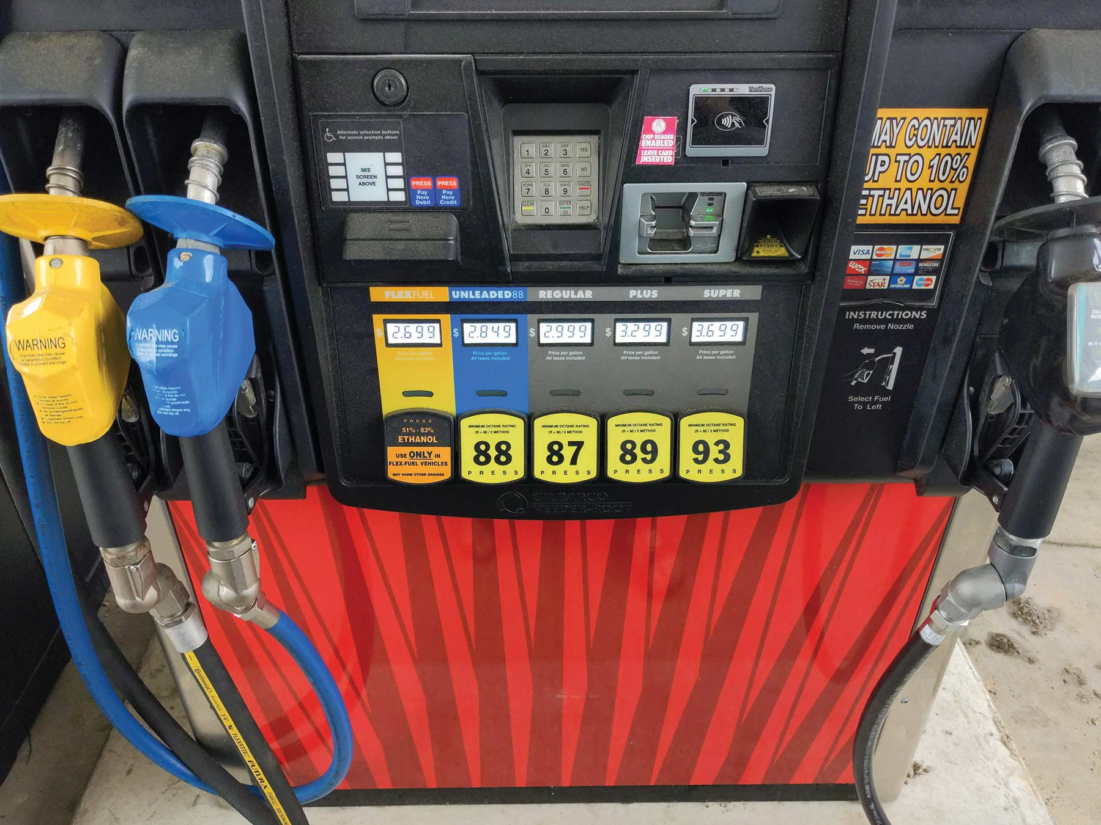

While E15 is a whole can of worms politically and economically, and can be directly harmful to motorcycle engines, E10 still may damage motorcycles according to Chris Real, owner of DPS Technical, Inc.

Real pointed out that fueling up with E10 isn’t a catastrophe for newer, fuel-injected motorcycles, but the danger for motorcycles burning any form of ethanol boils down to water.

“The ethanol fuels are pretty good absorbers of water and that is where our root problem lies,” Real told American Motorcyclist. “The corrosive effect that water has leaves the components open to degradation and deposits, which are especially bad for carbureted bikes.”

Because gasoline has a volumetric expansion of 15 to 20 percent when it gets hot, it brings air and humidity into the tank — which finds its way into the fuel system — when it cools.

While carburetors aren’t as common as they once were, plenty of motorcycles still use them and motorcyclists know all too well how much of a pain they are to rebuild, and how expensive it is to have them rebuilt.

But even for fuel-injected motorcycles, deposits from ethanol gasoline can have bad outcomes.

“Mainly, for fuel injection systems, the sprayer nozzles are these tiny little holes that, if clogged, can actually be very dangerous,” Real said. “Imagine you are coming off a stop light and the bike stalls because some crud blocked the nozzle.”

Besides that, fuel pumps and fuel filters can also be damaged by a buildup of deposits. To mitigate the chance of a failure here, Real advises using a fuel stabilizer additive when parking any bike, or using non-ethanol fuel (available at some stations) or even prepackaged ethanol-free chainsaw gasoline that can be found at hardware or home improvement stores. The prepackaged fuel is especially useful for vintage and carbureted bikes.

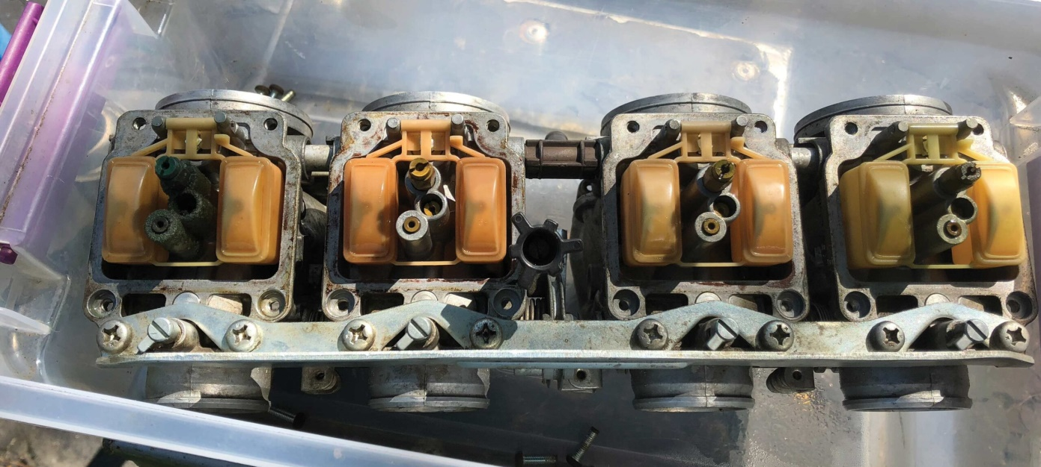

Another concern with ethanol-laced fuel is shelf life. Typically, corn gas has a shelf life of two to three months, while non-ethanol fuel is rated for six months. Besides using a fuel additive to keep the gas healthy, Real advised keeping the tank filled to limit headspace for air and humidity to get in.

Ethanol-laced fuels can also drastically reduce fuel economy because they don’t have the same amount of latent stored energy, which results in substantially less power potential per volume. But many real-world variables, such as ambient temperatures, tank temperature, engine displacement (fuel economy more drastically decreases in motorcycles under 200cc), weather conditions and, most importantly, rider behavior on the throttle and transmission shifting, factor into reduction of fuel economy. Basically, riders will NOT go as far on ethanol-laced fuels.

“Fuel economy is one of the main tradeoffs with ethanol fuel,” Real said. “We are being force-fed these fuels and we will have to contend with them.”

Basically, he explained, for consumers to safeguard their motorcycles, they need to be aware of what they fill up with at the pump, of engine gasoline requirements, and also practice good storage and maintenance habits.

“If the manufacturer says the bike is all good on E10, groovy…until you store it. Definitely don’t use E15, and for sure don’t use that E85 flex-fuel stuff because that can park you,” he said, adding that consumers should be aware that E85 is 85 percent ethanol and commonly confused with E15.

The AMA has been steadfast in its stance for proper labeling at the fuel pump to better educate and warn consumers of what they’re putting in their bikes, and the data bears out that concern. Proponents of ethanol-blended fuels who have clashed with the AMA claim that because it’s not approved for motorcycles, there is no concern.

However, marketing gimmicks increased those concerns. Sure, unless the pump says no ethanol added, consumers are guaranteed to get an E10-level corn additive. But in recent years, that juiced-up cousin E15 has been deliberately labeled as Unleaded 88 or 88 Octane (while E85 flex fuel is not clearly differentiated). Most of the time warning labels for gasoline with 15 or 85 percent ethanol are either missing, obscured, prone to falling off, or misleading. There is no reason whatsoever to label illegal and harmful E15 as “Unleaded 88” unless you’re actively trying to hide what it is from consumers.

“No consistency. No clarity. No protection for the consumer,” the National Marine Manufacturers Association has called these marketing gimmicks.

The Outdoor Power Equipment Institute has called it “disingenuous,” citing concerns of misfuelling and the need for improvements in pump labeling. A 2020 consumer study by the organization found that only 22 percent of consumers knew Unleaded 88 or 88 Octane was E15 in disguise! It also found that 64 percent of consumers assume that gas sold at the pump is safe for any engine.

So, when filling up at the pump and storing your motorcycle, here are some general rules to follow:

* Research the recommended fuel for your bike. If it says E10 is not recommended, don’t use it if you can help it (sometimes you can’t).
* Pay attention to the labels. If it doesn’t say ethanol-free, you are getting 10 percent corn regardless of the octane level.
* Never use the E85 flex fuel approved for certain passenger vehicles.
* If it says 88 anywhere and is cheaper, remember that’s really just E15 with makeup.
* Store your bike properly. Use fuel stabilizers, empty the carb bowls if possible, and keep a full tank for carbureted bikes. Pour in pre-packaged ethanol-free fuel for fuel injected bikes.

Tech Tip

# Dodging the Dangers of the First Spring Ride

## **Read these important tips before rushing out on your first ride of the season.**

**[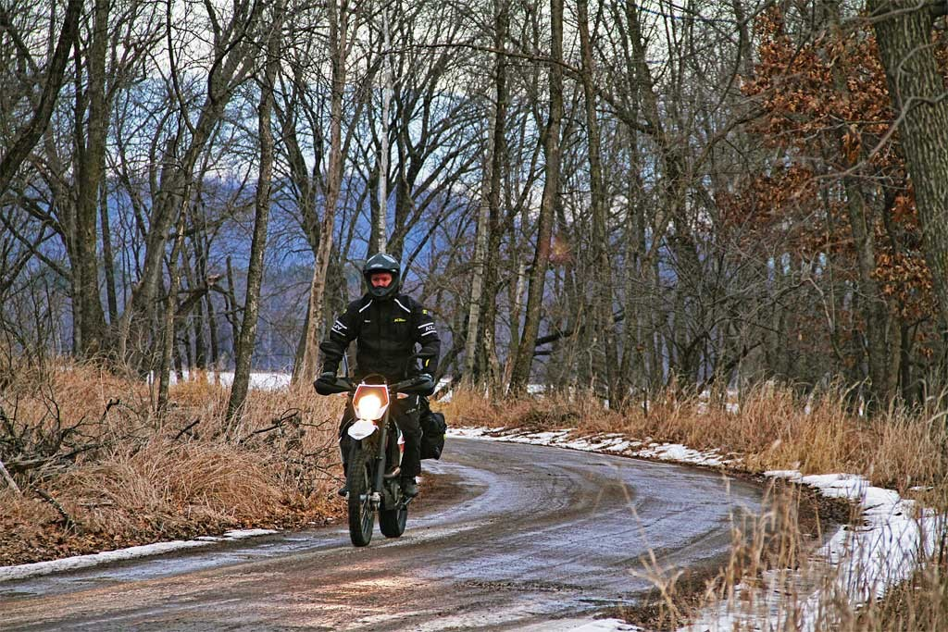](https://www.advpulse.com/wp-content/uploads/2015/03/spring-ride-after-winter-motorcycle-storage-1024x683.jpg)After months of cold weather, Spring Fever can cause you to hastily embark on your first ride of the season.**

Winter is the most loathed time of year by motorcyclists and those of us that live in colder climates suffer even more while enduring months of winter motorcycle storage. Once the weather warms up though, we are typically itching to get our bikes out of storage for that first ride of spring. But before you hastily push your bike out of the garage and thumb that starter button, there are a few things you should check to help ensure your first ride is a successful one.

**Pre-Ride Bike Inspection**

If you prepped your bike for the winter by adding [fuel stabilizer](http://www.amazon.com/STA-BIL-22214-Fuel-Stabilizer-oz/dp/B000B68V6I?tag=ap0db8-20) and either removed your battery or had it on a [trickle charger](http://www.amazon.com/Battery-Tender-021-0156-Charger-Model/dp/B000NCOKQK/?tag=ap0db8-20), then your bike should come to life without too much trouble. Once you have the bike running, it’s a good time to give it a thorough mechanical inspection to make sure it’s safe to ride.

A great checklist for inspecting your bike after a long winter motorcycle storage is the Motorcycle Safety Foundation’s [T-CLOCS checklist](http://www.msf-usa.org/downloads/T-CLOCS_Inspection_Checklist.pdf). The T-CLOCS checklist is extensive and it’s a good idea to check all of the items listed there, but it can be overkill for just a few months in storage. At the very least, you should check these items on your motorcycle:

* Fuel:  Gasoline can break down quickly and clog up injectors and jets. The easiest way to avoid this is to winterize your bike by adding fuel stabilizer before you put your motorcycle into storage. Nevertheless, your first ride of the season should be to the gas station to get a tank full of fresh fuel.
* Tires:  Your tires can deflate and crack while in winter storage, so check them over well and make sure they are properly inflated before going on your first ride.
* Fluids:  Check your oil, antifreeze and brake fluids to make sure they are at proper levels. If you didn’t change your oil before putting your motorcycle into winter storage, now is a good time. Check the floor around your bike and make sure there aren’t any leaks. If you find leaks, try to track down the source before starting the motorcycle.
* Chain:  If your bike is chain driven, make sure the chain is properly lubricated and doesn’t have any tight spots or excessive wear. Also, look for worn sprockets and make sure the chain tension is adjusted to manufacturer specifications.
* Suspension:  Rust can build up on suspension components during winter motorcycle storage leading to premature failure of seals. Look for light rust or tarnishing on the fork tubes and the rear shock shaft. If you find any rust build up, you can usually remove it with steel wool.
* Partially Completed Projects:  When you put your motorcycle away for winter storage, there may have been a project or two you started but never completed. You can easily forget about these projects after months have passed by. Give the bike a good once over to make sure there aren’t any loose bolts or clamps that could give you trouble on your first ride of spring.

**[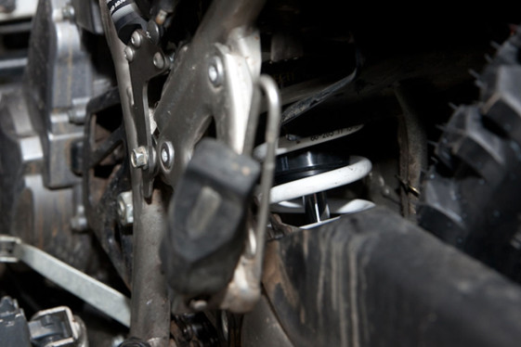](https://www.advpulse.com/wp-content/uploads/2015/03/shock-shaft-rust.jpg)**

**Check the rear shock shaft and fork tubes for rust that may have accumulated during winter storage to avoid torn seals.**

**Taking Your First Spring Ride**

Assuming you’ve inspected your motorcycle and prepared it for the first ride, then you’re probably eager to get out on the road (or trail). Here are a few more things to keep in mind before you rush off on your first ride in months.

* Full Riding Gear:  So you think the bike’s ready and you want to go around the block for a quick test ride? Don’t skimp on the riding gear. Accidents can easily happen on that first test ride when the bike’s condition is still iffy, so make sure you are fully protected. Once you go out for a longer ride, always bring along cold weather gear even if temperatures are warm. In these early days of spring, you never know when winter might make a surprise return.
* Getting in Riding Shape:  It’s great to be riding again and it may feel like you haven’t missed a beat but your skills are not going to be as good as they were last fall. Your reaction speed and timing can be a little off and corners can sneak up on you unexpectedly. Start out with a nice easy pace and slowly blow off the cobwebs on both man and machine. The first ride isn’t the time to be pushing your limits. An accident now could easily end your riding season before it’s even begun.
* Stay Connected:  Sure, your bike may have seemed fine while it was running in the garage, but there could be some hidden issues that develop miles down the road. You may just be planning a short shakedown ride, but don’t forget to carry a mobile phone or GPS Messaging Device that will allow you to call for help and avoid being stranded should you encounter mechanical problems.
* Unpredictable Road Conditions:  Many riders wait until there have been a few rain showers to help clean off the roads before taking their first ride of the season. If you can’t wait for the roads to get cleaned off, be aware of the hazards you may encounter. Road crews typically use salt or sand to melt ice on the roads during the winter and much of it is still waiting for you in the spring. Also look out for ice hiding in the shadows and snow melt running across roads that can be extremely slippery. Corners and intersections are where you are most likely to encounter bad traction, so stay alert to avoid logging your first crash of the year.
* Ride Defensively:  You need to be aware that other motorists haven’t seen motorcycles on the road for months and they may have forgotten they share the road with you when spring comes around. During this time of year more than any other, you need to be on the lookout for cars straying into your lane and turning in front of you. It’s your life on the line, so take responsibility and assume they don’t see you — always drive defensively.

[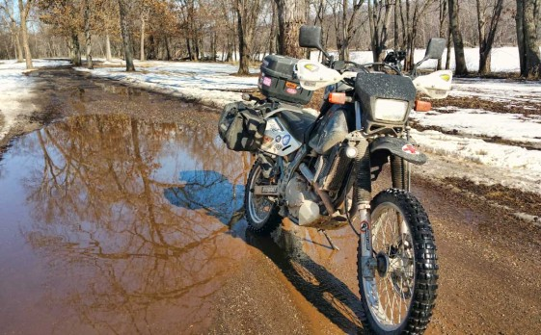](https://www.advpulse.com/wp-content/uploads/2015/03/slick-roads-of-spring.jpg)

**Snow melt, hidden ice and wet roads are all hazards to contend with during early spring rides.**

Despite all the dangers of early spring rides, there’s nothing like the feeling of being back on the bike again. If you prepare your bike and ride cautiously, you can jump start the season while your buddies are indoors still dreaming about going for a ride. Get out there and ride!

Joke of the Month



Product of the Month

# BTSHUB Blind Inner Bearing Puller Slide Hammer Set 5pcs Hole Remover Extractor Set

A Blind Bearing Puller is used for pulling jobs requiring an internal pull, such as wheel bearings. Most sets come with multiple expandable collets. Insert the collet, expand it to fit the hole, and then attach the slide hammer. A slide hammer is a tool with a long round shaft on which a hammer weight slides. The force produced by moving the weight quickly toward the end of the shaft is used for pulling out the bearing.

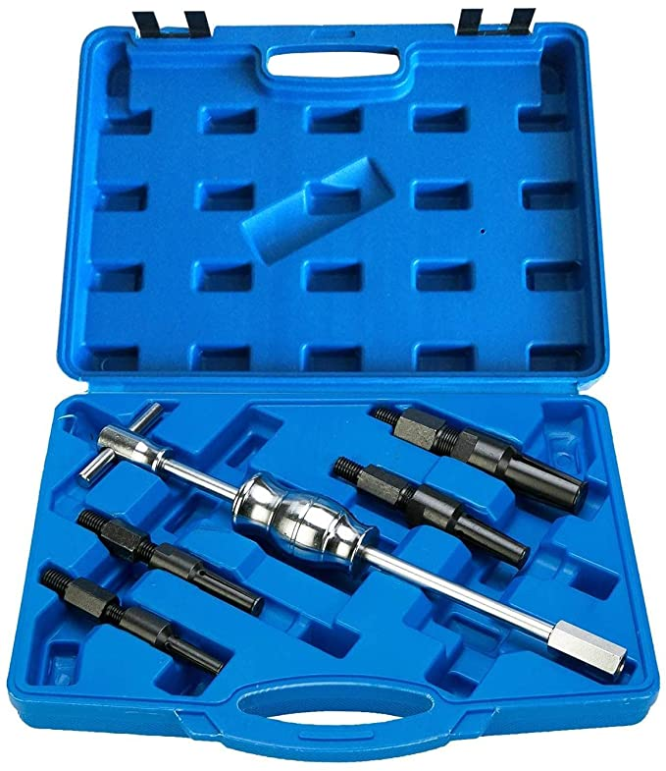

* Bearing Extractor Collets With Internal Capacity From 3/8" (10mm) To 1-1/4" (32mm)
* Includes 1 pc Slide Hammer Assemble & Clamp
* Open Clamps By Turning Handle Clockwise To Snug Against The Bearing
* For Pulling Out Evenly Without Damage The Parts
* Fully Chromed Carbon Steel Slide Hammer, 15" (382mm) Overall Length

There are many set available for purchase. Here is an affordable one from Amazon. [It can be purchased by clicking here for $29.99.](https://www.amazon.com/BTSHUB-Bearing-Puller-Remover-Extractor/dp/B08GG5BV31/ref=sr_1_16?keywords=blind+bearing+puller&qid=1648766925&sr=8-16)

Club Products

To order specialty products: To use this option:

1. Go to [www.sanmar.com](http://www.sanmar.com) . The webpage you see below will display.

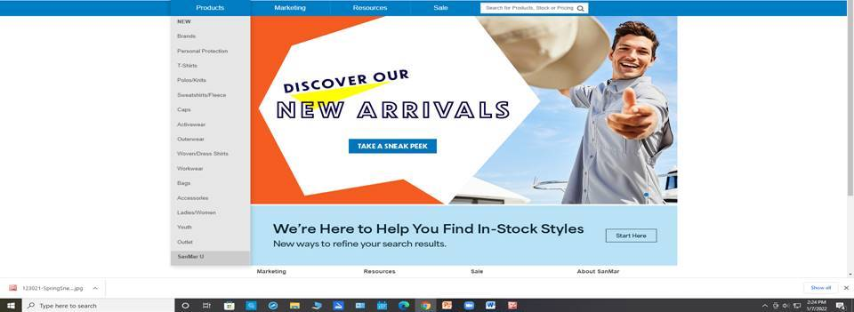

1. Once there, peruse the site to find a product you want to purchase.
2. Note the following information:
   1. Product number
   2. Product description
   3. Product size
   4. Product color
   5. Club logos:
      1. Logo size
      2. Logo placement on product
      3. Logo colors
3. Provide information to Roy and he will place order. Roy can be contacted at 217-721-8446 or by email [roy.sims@comcast.com](mailto:roy.sims@comcast.com)
4. When product arrives, Roy will make arrangements to receive payment and delivery.

Our goal is to provide a valued service to club members. Please bear with us as this process is new to all of us and not all factors are not within our control.

Sickness and Distress

This is an opportunity to say goodbye to our brother Jim “Wedge” Grahn following one last ride. The time for the Toast will not be 1:30 pm as noted. The new time will be announced later. This will allow the club to host it previously schedule annual picnic allowing members to also attend the ride and Toast.

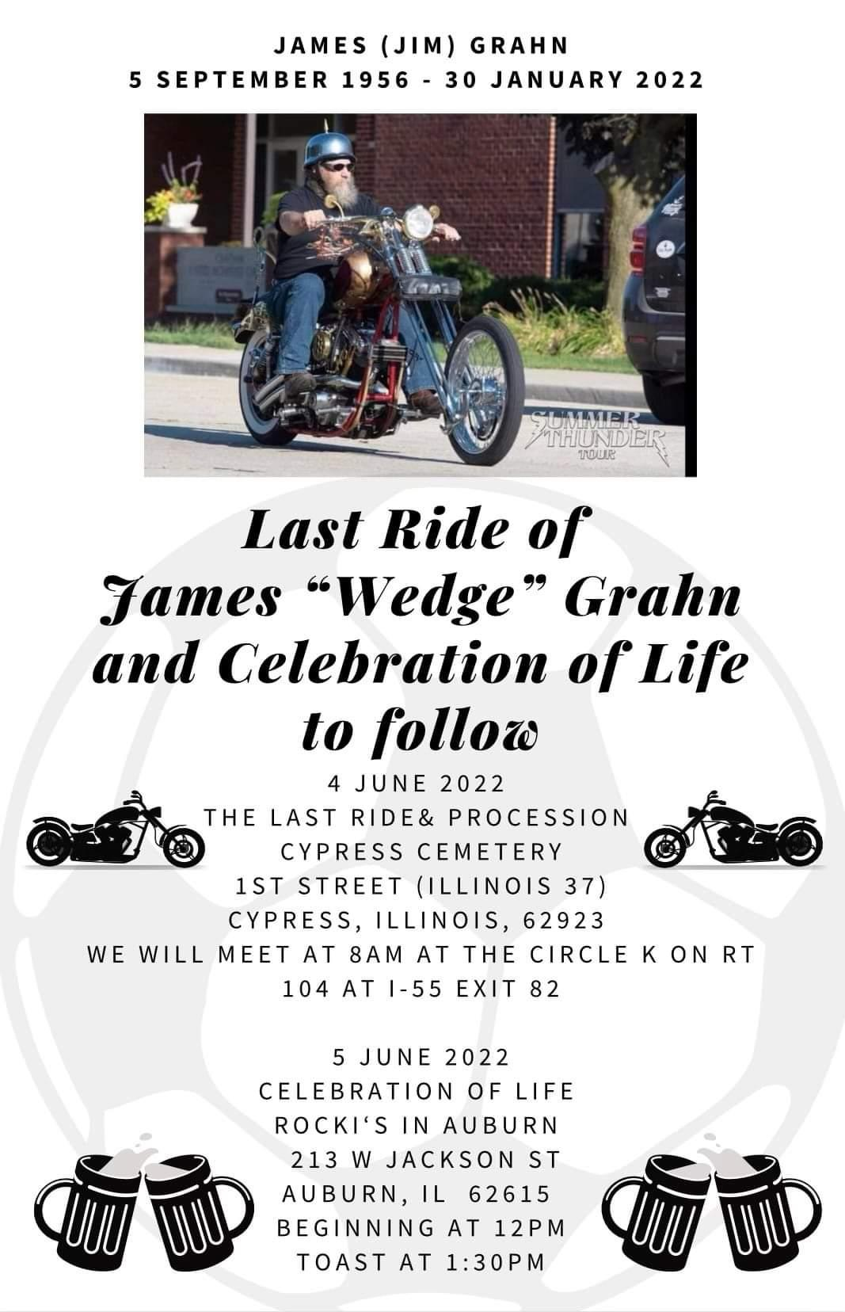

Classified Ads

* Roy Simms is looking for a 2016 Club Calendar for his museum. Please contact Roy at 217-721-8446 or by email [roy.sims@comcast.com](mailto:roy.sims@comcast.com) if you can help.
* Vapor blasting services. Vapor blasting is a surface refinishing process that was originally used by Rolls Royce in England many years ago, to clean and resurface aluminum jet engine parts to eliminate corrosion and facilitate inspection. It is quite simply cleaning via high-pressure surface blasting, but instead of dry abrasive media, it uses a slurry of water, compressed air, detergents and abrasive media. The vapor created is much gentler to soft aluminum than other processes, yet it will remove a microscopic layer of oxidized metal and corrosion. This process also seals the pores of the aluminum making it look better longer, and be more resistant to future corrosion. Vapor blasting differs from dry blasting in other respects as well – it will not dimensionally change a part, the media used is much finer and gentler, and the resulting surface is much smoother and shinier.

Contact Mark Morrison at 309-510-4189 or [mmorr26407@aol.com](mailto:mmorr26407@aol.com) if interested.

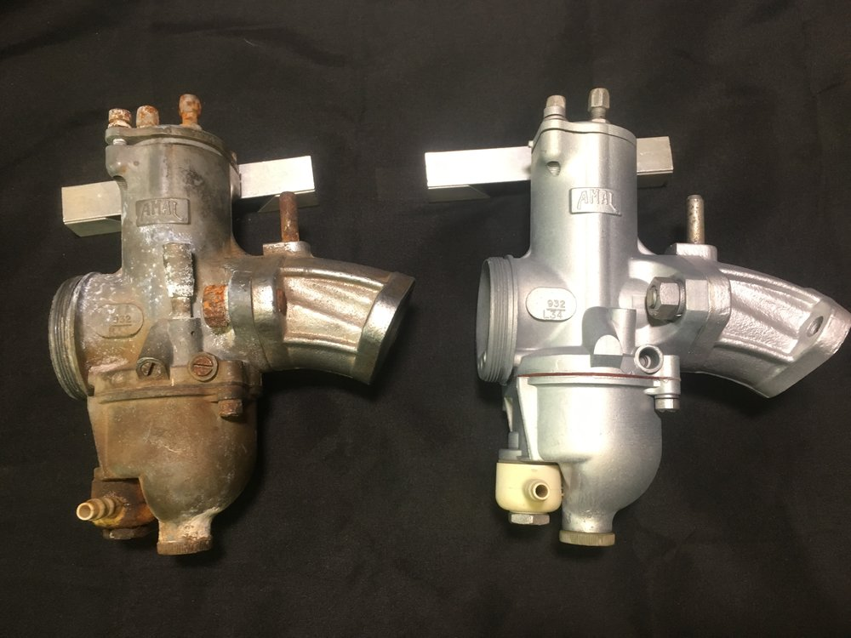

Before and after pictures

**Send classified submissions to Mark Morrison at** [**mmorr26407@aol.com**](mailto:mmorr26407@aol.com)

Contacts

Vintage Iron Riders

3985 N. 8th Street Rd. Springfield, IL 62707

<https://www.virmc.com/>

**Visit us on Facebook**

[](https://www.facebook.com/groups/1020653317952869/)

**Officers**

President - George Tinkham

Phone 217-753-2737

Email [coolbreeze@att.net](mailto:coolbreeze@att.net)

Vice Pres – John Anderson

Phone 217-725-4509

Email [fireball398@gmail.com](mailto:fireball398@gmail.com)

Treasurer - Mandi Powell

Phone 217-416-5575

Email [mandiu828@aol.com](mailto:mandiu828@aol.com)

Sec/ News/Web - Mark Morrison

Phone 309-662-5371

Email [mmorr26407@aol.com](mailto:mmorr26407@aol.com)

Events – John Langheim

Phone 217-652-8996

Email [langheim729@comcast.net](mailto:langheim729@comcast.net)



**“Get your kicks on RT66!”**