# Vintage Iron Riders

A Vintage Motorcycle Club founded in 2003 whose members are primarily located in Central Illinois

Cen

# Vintage Iron Vintage Motorcycle Club founded in 2003 whose members are primarily located in Central Illinois

March 14, 2022

Vintage Iron Monthly

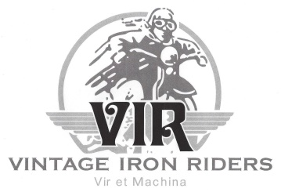

President’s Prattle

**A Good Reason to Ride**

Earlier this month, I had two farm meetings south of town.  I would usually drive my truck to meetings like those because of the tools and other items in the truck.  The weather and relatively clear roads, however, were just too much to resist.  So, I mixed business with pleasure.  I usually do not ride when there is salt residue on the road, but I figure that I will rust out before the motorcycle does.  Besides, you can buy replacement parts, but you cannot buy a nice day for riding.

Now that gasoline prices have shot up, we have yet another incentive to ride a motorcycle.  Talk about a “twofer”: You experience the joy of riding *and* you save money on fuel at the same time!  It has been over a month since I bought gasoline, and it may be another month before I do it again.  What an incentive to ride: motorcycling is fun and economical.

Winter has finally loosed its grip and warmer weather is settling in.  The rain this weekend should wash the remaining salt from the pavement.  Even the dreaded pandemic is easing, albeit after leaving its mark on our club.  Yes, Spring is finally beginning to emerge like crocuses through the snow.

It’s about time!!

George Tinkham

Inside this issue:

Upcoming Events 1

Member Meeting Minutes 2

Tech Tip 3

Joke of the Month 4

Product of the Month 5

Club Products 6

Contact Information 7

Classified Ads 7



Meetings held at 7:00 pm every 3rd Wednesday of each month at Top Cats Chill and Grill located at:  3211 Sangamon Ave., Springfield, IL.  217-528-4201

**Next Member Meeting**

**March 16, 7:00pm**

Upcoming Club Events

* Club picnic will be June 5th in Chatham again.
* The Distinguished Gentleman's Ride is Sunday, May 22nd, 2022
* July 23 is the American Legion Cruise In & Open House. Club is planning to participate.
* 12/9/22 - Annual Christmas Party 6:00PM, Poe’s On the Hill, Springfield.



Member Meeting Minutes

**February 16, 2022**

Meeting was called to order at 7:02 p.m. at Top Cat’s. A Quorum was established.

* Please turn off cell phone
* The Flag of our Country was on display, and George led the Pledge of Allegiance
* George led Club in prayer
* Minutes approved as published

**Reports:**

* Treasurer
  + Current Balances
    - Jeff White Memorial Fund $1,465.08
    - General Fund $3,326.28
    - Total $4,791.36
  + Approved by acclimation.
* Events
  + Annual Club picnic will be June 6 in Chatham.
  + Club plans a Jim Grahn Memorial ride this spring.
  + Plans are developing for annual wiener roast this fall.
  + Rumble Around the Lake is starting up soon. Club is planning to participate in some stops.
  + The Distinguished Gentleman's Ride is Sunday, May 22nd, 2022
  + July 23 is the American Legion Cruise In & Open House. Club is planning to participate.
  + George is looking at a Ride-To-Ron’s this year in the fall.
  + 12/9/22 - Annual Christmas Party 6:00PM, Poe’s On the Hill, Springfield.
* Products
  + 2022 calendars are getting low. We have 12 sponsors this year.
  + New Club business cards will have QR code on one side.

**Old Business:**

* None

**New Business:**

* Lance Gilbert was approved for membership.
* Club is looking to update club brochures.
* Club is participating in IDOT conference.

**Sickness and Distress**

* + Jim Grahn passed away January 30.
  + Hank Charles has his pacemaker replaced.
  + Matt Simms is being treated for cancer.

Adjourned at 7:50 p.m.

**Monthly Board Meeting**

**Reminder** **April 6, 6:00pm**

Monthly Board meetings held every first Wednesday of each month at 6:00pm at Bernie & Betty’s Pizza located at:  1101 South Spring Street, Springfield, Illinois. 217-528-8121. All members welcome.

***The purpose of this organization is to promote the motorcycling interests of its members in an atmosphere of fellowship and civility.***

***It includes helping establish contacts and communication with others whose experience, knowledge, and access to parts and materials might assist those members in the acquisition, restoration, maintenance, and use of antique and vintage motorcycles.***

***​***

***Above all, the purpose of this club is to have fun!***

Tech Tip

**Tips for Breaking in Motorcycle Brake Pads**

New brake pads add an element of confidence when you’re riding your bike.

Effective braking power and shorter stopping distances are key ingredients to the overall handling profile of a motorcycle. The other advantage of [new brake pads](https://www.partzilla.com/catalog/aftermarket/parts/brake/brake-pads?utm_source=titan&utm_medium=blog&utm_campaign=text_link_click&UTM_content=tips-for-breaking-in-motorcycle-brake-pads) is that they protect your bike’s [rotors](https://www.partzilla.com/catalog/aftermarket/parts/brake/brake-rotors?utm_source=titan&utm_medium=blog&utm_campaign=text_link_click&UTM_content=tips-for-breaking-in-motorcycle-brake-pads). Old pads can eventually cut into the surface of the rotor, and in turn cut into your wallet by making you have to replace worn out parts more often.

After you [change the brake pads](https://www.partzilla.com/blog/honda/cbr/600/front/brake/pad/change) on your motorcycle, they need to be broken in. Brake pads are heat cycled over and over, and have to scrub off the momentum when you slow down. That means the pads need to reach a point of maximum effectiveness, and getting them there requires several steps.

**How to Break in Your Motorcycle’s Brake Pads**

One important thing to remember when you’re first breaking in your new pads is not to come to a complete stop with the brakes engaged.

The heat in the new pads may warp the rotors and damage the pads. An empty lot is a good place to start breaking them in, so you can have open space to accelerate and slow down without worrying about traffic.

1. Accelerate to about 30 miles an hour and aggressively apply the brakes. Don’t come to a complete stop, and keep the wheels turning. Repeat this 8-10 times.
2. Do the same thing but from about 60 miles an hour, again without complete stops. Slow the bike down, then reaccelerate and do it again. Repeat about 8-10 times.
3. Take a normal ride, and then cool the brakes down a bit.
4. Repeat the first step, but this time from about 45 miles an hour. Try to be smooth as you brake, and don’t lock the brakes down or over-modulate the braking power. Be steady.
5. For the first 200-300 miles, continue to take it easy. Over that time, you’ll start to feel an improvement in braking responsiveness.

Never touch the rotors. Obviously, you don’t want to touch them when they’re hot, but even when they’re cool the oils on your hands can contaminate the surfaces. Also, take special care if you’re working with fluids around your brakes, as even [brake fluid](https://www.partzilla.com/catalog/aftermarket/tools-and-supplies/additives-fluids/brake-fluid?utm_source=titan&utm_medium=blog&utm_campaign=text_link_click&UTM_content=tips-for-breaking-in-motorcycle-brake-pads) can harm them if it gets on the rotors.

The brake system on any machine takes a pounding from heat and momentum. Breaking in the brake pads properly enhances your motorcycle's stopping power, but it also keeps you safer, so don't cut corners and take the time to break in those brake pads!

Joke of the Month



Product of the Month

# SyncPro™ Carb Tuner

[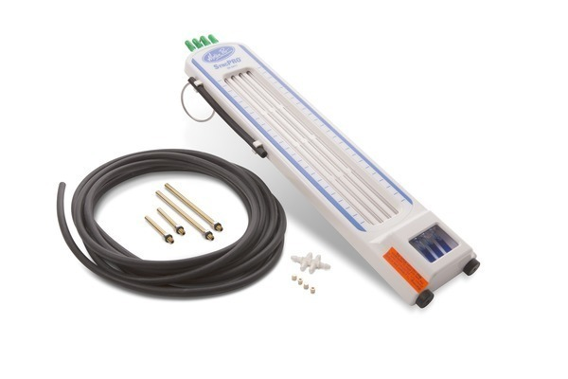](https://motionpro.s3.us-west-1.amazonaws.com/variants/Fy4KpDSN9tkYZJVx9YMpN7v3/073213f866e4695e5381635c4ece2f6ad498892f3b238bf6f181e0136911ddcb)

* Precise four channel vacuum indicator designed specifically for intake synchronization of engines with multiple carburetors or throttle bodies (maximum vacuum rating for this tool is 40cm Hg)
* Mercury-free design
* For use with any 2, 3 or 4 cylinder four stroke motorcycles
* Spill proof design allows tool to be stored in a horizontal or vertical position
* Easy to read scale for precise synchronization
* Unaffected by ambient pressure changes
* Includes hang hook to clip onto the handlebars for easy use
* Rugged, impact resistant ABS enclosure with convenient storage area for adapters
* Rubber feet on enclosure bottom helps prevent sliding
* Includes hoses, 5mm adapters, in-line restrictors and instructions
* 5mm adapters are used on many Honda and Suzuki models
* Optional 6mm adapters are available for use on most Yamaha models
* Most Kawasaki models do not need adapters
* Patented design
* Accessories: [08-0168](https://www.motionpro.com/product/08-0168) 6mm short adapters(set of 4); [08-0013](https://www.motionpro.com/product/08-0013) 5mm brass adapters(set of 4); [08-0040](https://www.motionpro.com/product/08-0040) 6mm brass adapters Yamaha (set of 4); [08-0014](https://www.motionpro.com/product/08-0014) replacement hose set, [08-0426](https://www.motionpro.com/product/08-0426) Restrictor Jet (set of 4)

[The SyncPro can be purchased here for $109.99.](https://www.motionpro.com/product/08-0411)

Club Products

To order specialty products: To use this option:

1. Go to [www.sanmar.com](http://www.sanmar.com) . The webpage you see below will display.

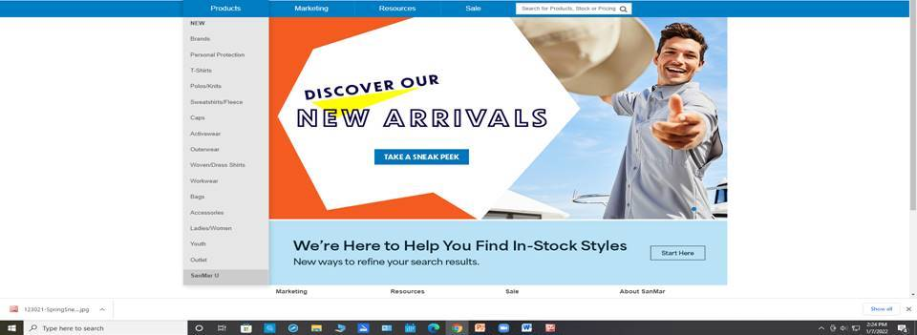

1. Once there, peruse the site to find a product you want to purchase.
2. Note the following information:
   1. Product number
   2. Product description
   3. Product size
   4. Product color
   5. Club logos:
      1. Logo size
      2. Logo placement on product
      3. Logo colors
3. Provide information to Roy and he will place order. Roy can be contacted at 217-721-8446 or by email [roy.sims@comcast.com](mailto:roy.sims@comcast.com)
4. When product arrives, Roy will make arrangements to receive payment and delivery.

Our goal is to provide a valued service to club members. Please bear with us as this process is new to all of us and not all factors are not within our control.

Classified Ads

Vapor blasting services. Vapor blasting is a surface refinishing process that was originally used by Rolls Royce in England many years ago, to clean and resurface aluminum jet engine parts to eliminate corrosion and facilitate inspection. It is quite simply cleaning via high-pressure surface blasting, but instead of dry abrasive media, it uses a slurry of water, compressed air, detergents and abrasive media. The vapor created is much gentler to soft aluminum than other processes, yet it will remove a microscopic layer of oxidized metal and corrosion. This process also seals the pores of the aluminum making it look better longer, and be more resistant to future corrosion. Vapor blasting differs from dry blasting in other respects as well – it will not dimensionally change a part, the media used is much finer and gentler, and the resulting surface is much smoother and shinier.

Contact Mark Morrison at 309-510-4189 or [mmorr26407@aol.com](mailto:mmorr26407@aol.com) if interested.

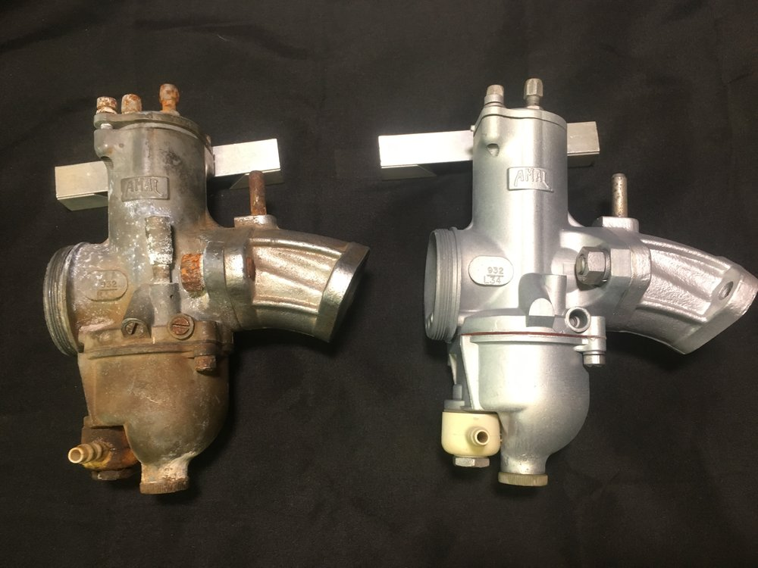

Before and after pictures

**Send classified submissions to Mark Morrison at** [**mmorr26407@aol.com**](mailto:mmorr26407@aol.com)

Contacts

Vintage Iron Riders

3985 N. 8th Street Rd. Springfield, IL 62707

<https://www.virmc.com/>

**Visit us on Facebook**

[](https://www.facebook.com/groups/1020653317952869/)

**Officers**

President - George Tinkham

Phone 217-753-2737

Email [coolbreeze@att.net](mailto:coolbreeze@att.net)

Vice Pres – John Anderson

Phone 217-725-4509

Email [fireball398@gmail.com](mailto:fireball398@gmail.com)

Treasurer - Mandi Powell

Phone 217-416-5575

Email [mandiu828@aol.com](mailto:mandiu828@aol.com)

Sec/ News/Web - Mark Morrison

Phone 309-662-5371

Email [mmorr26407@aol.com](mailto:mmorr26407@aol.com)

Events – John Langheim

Phone 217-652-8996

Email [langheim729@comcast.net](mailto:langheim729@comcast.net)



**“Get your kicks on RT66!”**